Inside This Issue
1 | Truffle Thieves
2 | Truffle Dog Training? / Truffle Haiku
4 | Recipe – Veal Scaloppine with Truffles
6 | Meeting Minutes
7 | Monster Mushroom

The North American Truffler
Journal of the North American Truffling Society

Volume 29, Issue 2 Spring 2010

.


Public’s help sought to curb tree damage from trespassing truffle thieves

For most of us, “truffle” brings to mind an elegant chocolate confection. But for forest landowner Roy Marshall, the other truffle, a fungus that thrives in the soil around his Douglas-fir trees east of Florence, has become something of an attractive nuisance.

“I have 15 acres of trees between the road and the river,” he said, “and last year they dug up the whole bottom.”

For the third year in a row, truffle thieves have trespassed on Marshall’s carefully managed woodland along the Siuslaw River to unearth the gourmet delicacies that grow a few inches below the surface. Wielding heavy, long-tined rakes, they dig down 14 to 16 inches in the soil from the base of the tree out to a distance of 15 feet or more. In the process of collecting their crop, worth $80-100 per pound wholesale, the illicit harvesters lay bare the tree roots.

“Exposed roots could affect the conifer’s health or weaken the tree during a storm event,” said Oregon Department of Forestry’s Delos Devine.

The truffle thieves have also left their mark on the land in other ways. Evidence of warming fires at the digging sites concerns the forester, since a change of weather could rekindle smoldering ashes into a wildfire. And littering often accompanies the harvest, with beer cans and other trash strewn everywhere.

Anyone observing suspicious behavior in the area, such as hand-raking or digging around trees, is encouraged to call the Department of Forestry’s Florence Unit office, 541-997-8713.

Legitimate truffle hunters stress the importance of minimizing disturbance to the environment when pursuing their hobby. The Corvallis-based North American Truffling Society provides tips in its “Ethical, Sustainable and Common Sense Guide to Harvesting Truffles," available on the web, www.natruffling.org. Dan Luoma, an Oregon State University assistant professor who researches forest mycology (the study of fungi), said the variety of truffle under Marshall’s trees is likely the Oregon Black truffle, though the Oregon White truffle also occurs on the west side of the Coast Range.

Some truffle hunters are hanging up their rakes to rely instead on specially trained dogs to locate their culinary treasures. This method causes much less disturbance to tree roots. And because ripe truffles have a strong scent, dogs home in on them, leaving immature fungi in the soil to develop and grow. “It is just in the last couple of years that use of dogs has gotten serious consideration in our area,” he said, “mainly because a market has now developed that has gotten the attention of dog trainers.”

They grew up spoiled and lazy, and when many years later the good fairy returns, disguised as an old woman, they refused her hospitality and food. To punish them, the fairy buries all of the truffles underground and turns the selfish children into pigs to root them out.”

Quoted from pages 29&30 of:

Hall, Ian R.; Brown, Gordon T.; Zambonelli, Alessandra. 2007. Taming the truffle: the history, lore, and science of the ultimate mushroom. Portland, OR: Timber Press. 304 p.

Truffle Haiku

From the Urban Farm Stand Newsletter.

What Happened to The Truffle Pig by Aaron Padilla
The snout in loam, digs,
nostril-cringe, quiver and bite!
"So we ate the pig."

Bonni Goldberg
Who can resist you?
Dark, musky, nutty truffle
Aphrodisiac

Andy Oldshue & Matthew Weatherman
If I stole truffles
You could say I was not nice
But still a fun guy

Geo
I see overnight
a mushroom grew as quickly
as my love for you

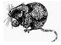

Visit the NATS Website for a full-color version of The Truffler!
www.natruffling.org

Watch fungi grow: http://www.wimp.com/fungigrow/

Truffle Dog Training?

NATS is considering offering a truffle dog training class in partnership with Jean Rand. No dates, times, or costs are set yet. At this time, NATS is gauging interest in such a class. If interested, please send an email to Marilyn Hinds at: mkhinballard@peak.org.
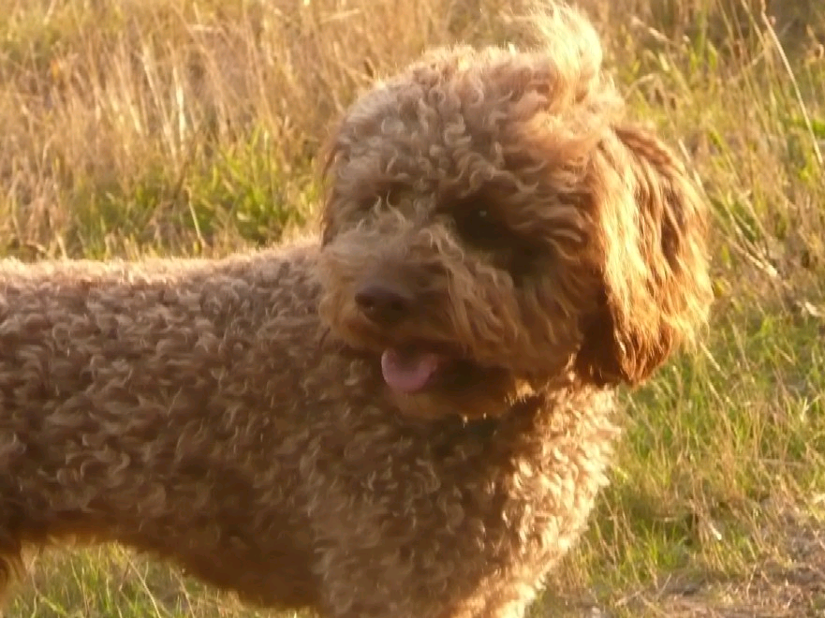
Call for Recipes

NATS is putting together a new and improved cookbook. So, if you have some tasty truffle-and mushroom-related recipes you’d like to share, please send them in! Sylvia is handling the cookbook, so please email those recipes to her at: sylviahdonovan@yahoo.com.
The Story of the Truffle

“One legend told in the Périgord region is about an old woman, tired and hungry, losing her way in the woods. At last, she stumbles upon a tumbledown house, the home of a man equally poor and old. He invites her in and offers her his meager meal of charred potatoes, cooked in the coals of a dying fire. The old woman is deeply touched by his generosity and sits down to peel the potatoes. Suddenly she is transformed into a beautiful fairy. ‘Lo, do not be alarmed old man,’ she says. ‘I am the fairy of the woods. You are a kind and noble person and from these poor potatoes, which you have humbly shared with me, will come the end of your trials and tribulations.’ Before his eyes, the charred potatoes are transformed into richly flavoured truffles. Despite becoming wealthy and respected throughout the region, the old man continues to be kind and helpful to all those less fortunate than himself, but the same cannot be said for his children.

Spring 2010
Calendar of Events

NATS April Foray
Place: Kittel’s in Yachats Oregon
Time: Sat. Apr. 3 at 11AM
Please see the NATS website for directions are more information.
NATS April Meeting
Place: Corvallis Multicultural Literacy Center
Time: Tue. Apr. 6 7:30PM
The speaker will be Dr. Darlene Southworth of Southern Oregon University, who will share her research on "Responses of truffles and mycorrhizas to brush mastication and prescribed fire." The meeting will be held at the Corvallis Multicutural Literacy Center at 128 SW 9th street in Corvallis (the big yellow house between Monroe and Madison avenues). There is parking on 9th street and in the dirt lot at the SW corner of 9thx1 and Monroe..
NATS May Meeting
Place: Corvallis Multicultural Literacy Center
Time: Tue. May. 4 7:30 PM
Speaker: TBA. See the NATS website for more information.
NATS May Morel Foray
Place: Near Camp Sherman
Time: Possibly May 15, Depending on Conditions.
See the NATS website in April for more information.

Reminder: Please Remember to Renew Your Membership for 2011.

A membership renewal form can be found on the NATS website. Please renew now! We appreciate the support of each and every member. A renewal form will be printed in the winter newsletter.

Editor’s Comments

It’s been in interesting late winter, with all the warm, and then cold weather. I’m anxious to see how this will affect spring forays, especially the morel crop. Rumor has it morels were seen in the Eugene early in early February!

I’m planning on publishing the next issue in Fall, 2010, so please get me any newsletter material to me by October. Thank you!

Jon Kenneke, Truffler Editor - jon@kenneke.com

Disclaimer

The information contained in The Truffler is to be used at your own risk. NATS, Inc., its officers, editors, and members are not responsible for the use or misuse of information contained in the newsletter. If you are unsure of mushroom identification or safety, please consult an expert. It’s better to be safe than sorry!

In addition, attending and participating in a NATS event is entirely at your own risk. No person associated with NATS, is either directly or indirectly responsible for anything that occurs during, or in transit to/from a NATS event. Be responsible.

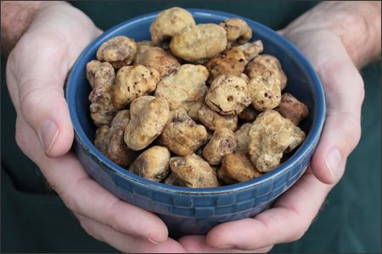

Veal Scaloppine with Truffles
Preparation time: 20 minutes
Serves 4
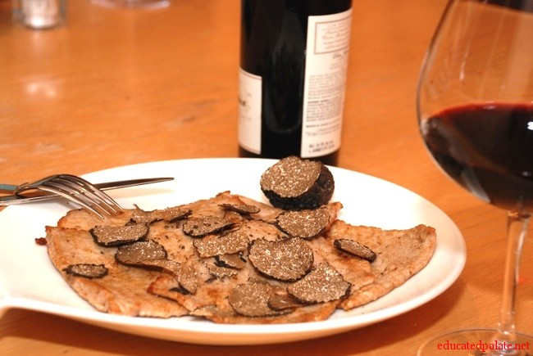
1 pound veal scaloppini
1 tablespoon vegetable oil
2 tablespoons butter
About ½ cup all purpose flour
Salt
Freshly ground black pepper
A 2-3 ounce fresh black truffle (Ed: Oregon Black preferred)

1. Pound the veal.
2. Spread the flour on a small plate. Put the oil and 1 tablespoon of the butter in a large skillet and place over medium high heat. While the oil and butter are heating, coat with the flour as many slices of veal as will comfortably fit in the pan, shaking off the excess. Do not dredge all the veal in the flour at once or it will become soggy.
3. When the oil and butter are quite hot, and the butter is just beginning to turn color, put in as many scaloppine as will comfortably fit. When they have lightly browned on both sides and lost their pink raw color, less than a minute per side, remove them, letting the excess oil drip back into the skillet. Set them aside on a platter. Flour and cook the remaining veal in the same manner. If the pan becomes too dry, add a little more oil when the pan is empty, and let it get hot before continuing. When all the scaloppine are done, season them with salt and pepper.
4. If there is more than a coating of oil left in the pan, pour it out. Pour any juices that the meat on the platter has released into the skillet and add enough water so that there is about 1/8 –inch of liquid in the pan. Use a wooden spoon to loosen the browned bits on the bottom of the skillet and let the liquid bubble away until it has reduced and thickened into a sauce, 1-2 minutes. Add the remaining tablespoon of butter and remove the pan from the heat. Stir the butter into the sauce then put the scaloppine back into the pan, turning each one in the sauce to heat them through. Place the scaloppine on a serving platter large enough to accommodate them in a single layer and pour the sauce over them. Use a truffle slicer or vegetable peeler to slice the truffle into thin shavings over the scaloppine. Serve at once.

Credit to: G. Hazan

Truffles Galore
By Greg Robeson (from the traveloregon.com blog)

I was first introduced to the elusive truffle in the early 1990s. It was a winemaker dinner featuring chef David Machado, who now oversees the Portland culinary triumvirate of Lauro Kitchen, Vindalho and Nel Centro. He started the meal with a simple creamy risotto with truffle oil. Simple, stark, decadent. The type of lick-the-plate clean dish that leaves you wanting more and becomes permanently etched in your culinary brain. I was in love.

So, when Travel Lane County invited me to be their guest at the Fifth Annual Oregon Truffle Festival this past weekend in Eugene, it took about five seconds to say “yes.”

I learned lots, including the fact that while three types of truffles (white, black and brown) are currently harvested in the Pacific Northwest, there are over 350 species living in these same forests. White truffles are found from northern California to southern British Columbia and are called Oregon White Truffles. That’s what we were after. They fruit twice a year: the “spring” bloom from January through June, and the “autumn” from October to January.
My truffle adventure started with a trip to a former Christmas tree farm outside of Cottage Grove, south of Eugene. Douglas Firs, it seems, are the perfect breeding ground for the Oregon truffle. Zoe the truffle dog wasted little time proving we were in the right spot.
I was joined by a few dozen other truffle hunters — young and old. We learned to be nimble in moving the mulch of fir needles, in hopes of finding treasure just below the surface.
Dogs help maintain sustainable truffle patches…they only signal where the mature fruit is hiding, protecting young tubers from indiscriminate raking.
When washed, a white truffle looks like a small heirloom potato, with skin similar in appearance to a crimini mushroom. Although the hard freeze last December appears to have stunted the bloom, I was able to dig up a handful of small morsels and take them home.
After the truffle hunt, we headed to Sweet Cheeks Winery for an all-truffle lunch prepared by John Newman of Newman’s at 988 in Cannon Beach.
General Manager Lorrie Normann and winemaker Mark Nicholl poured their 2007 Pinot noir, 2008 Chardonnay and Pinot gris, and non vintage sparkling wine… all great matches with the menu. The crab ravioli with shaved white truffle was to die for. Poached pear with black truffle mascarpone cheese topped off the meal. Yum.

After lunch, we headed back to the Valley River Inn for a much needed rest before the next event: the grand dinner prepared by several of the state’s top chefs: Philippe Boulot of the Heathman Hotel and Bar, Naomi Pomeroy of Beast, Gabriel Rucker of Le Pigeon, and Pascal Sauton of Carafe, all hosted Rocky Maselli of Eugene’s Marche. The menu was seven courses of truffle heaven, prepared and served beautifully with Willamette Valley wines. If you’re serious about food, and want to learn just about everything there is to know about truffles, start making plans now for the 2011 Oregon Truffle Festival, which happens at the end of January.

Call for Newsletter Submissions

As you probably already know, The North American Truffler is published (almost) every quarter. If you, as a member of NATS, have articles, experiences, or recipes you would like to have published in the newsletter, please submit them to the editor. His email address is: jon@kenneke.com. Any type of format is accepted.

We also appreciate photographs of NATS forays and other interesting things!

MINUTES FROM THE NORTH AMERICAN TRUFFLING SOCIETY – Feb. Meeting

The members of NATS met for the monthly meeting in Corvallis, OR on February 9, 2010. Marilyn Hinds, president, called the meeting to order. She began by having those in attendance introduce themselves. Thank you to Pat Rawlinson for providing refreshments and to Nancy Weber for providing gluten free cookies.

A paper copy of the January meeting minutes were available to review. Marilyn asked if there were any changes to be made to the minutes. Mysti Weber motioned to accept them as is, Pat Rawlinson seconded and those in attendance voted to accept them.

Treasurer's report- Marilyn stated that Zelda Carter reported the checking account balance was $4900.

Membership report- Mysti Weber reported that NATS has 302 members from 2009 and 2010. Approximately 200 have not renewed their memberships for 2010 yet. She also stated that the website membership information has been updated since the last meeting. Marilyn reminded those in attendance of the increase in dues for the 2010 membership year, from $10 last year to $15 this year for an individual membership, an increase of $5 to $10 for the additional family member and $20, payable in US funds, for international membership.

Foray on Feb. 13- to Paul Bishop's property in the Beaver Creek area south of Oregon City, directions to the foray are on the website. Once a year Paul generously opens his property up to NATS for a foray. This year members who attend are encouraged to bring a potluck item to share.

Oregon Truffle Festival report- Sarah Uebel stated that the NATS booth at the festival was busy. Mysti Weber, Sylvia Donovan, and Loren McMahill volunteered at the booth. The 25 Field Guides sold out, we also sold 7 memberships with 2 extra family memberships, and a variety of other merchandise. The total sales for the day was $797 minus $15 for an extra entrance fee for the fourth volunteer.

Marilyn asked if the society should order more truffle field guides to have on hand or to wait until closer to the fall mushroom shows. Those in attendance agreed that the society should purchase 24 more field guides to have on hand before the fall shows.

A member asked if we had cookbooks available. The society sold out of the cookbooks that we had a while back. Marilyn asked if anyone would be interested in pursuing the possibility of making a new cookbook. Sylvia offered to help and requested that members send her their favorite recipe to her email address sylviahdonovan@yahoo.com. Those interested in helping with the cookbook should contact Sylvia.

Joyce Eberhart reported that last year NATS donated $500 to catalog the truffle specimens at the mycology lab and accession them to the OSU herbarium. The money was put into the work study program at OSU which provided a three to one match. Two people were hired to do the work and only about 25% of the specimens are left to complete.

Marilyn then introduced Jean Rand and Gusto. Ms. Rand presented her talk "Truffle Hunting with a Canine Partner and Basic Truffle Dog Training".

Oregon's monster mushroom is world's biggest living thing
By Jeff Barnard (The Independent)
The largest living organism ever found has been discovered in an ancient American forest. The Armillaria ostoyae, popularly known as the honey mushroom, started from a single spore too small to see without a microscope. It has been spreading its black shoestring filaments, called rhizomorphs, through the forest for an estimated 2,400 years, killing trees as it grows. It now covers 2,200 acres (880 hectares) of the Malheur National Forest, in eastern Oregon. The outline of the giant fungus stretches 3.5 miles (5.6 kilometres) across, and it extends an average of three feet (one metre) into the ground. It covers an area as big as 1,665 football fields.
The discovery came after Catherine Parks, a scientist at the Pacific Northwest Research Station in La Grande, Oregon, in 1998 heard about a big tree die-off from root rot in the forest east of Prairie City.
Using aerial photos, Ms Parks staked out an area of dying trees and collected root samples from 112. She identified the fungus through DNA testing. Then, by comparing cultures of the fungus grown from the 112 samples, she determined that 61 were from the same organism, meaning a single fungus had grown bigger than anything anyone had ever described before.
On the surface, the only evidence of the fungus are clumps of golden mushrooms that pop up in the autumn with the rain. "They are edible, but they don't taste the best," said Tina Dreisbach, a botanist and mycologist with the US Forest Service in Corvallis, Oregon. "I would put lots of butter and garlic on them."
Digging into the roots of an affected tree, something that looks like white latex paint can be seen. These are mats of mycelium, which draw water and carbohydrates from the tree to feed the fungus and interfere with the tree's absorption of water and nutrients. The long rhizomorphs that stretch into the soil invade tree roots through a combination of pressure and enzyme action.
In 1992, another Armillaria ostoyae was found in Washington state covering 1,500 acres, near Mount Adams, making it the largest known organism at the time. "We just decided to go out looking for one bigger than the last claim," said Gregory Filip, associate professor of integrated forest protection at Oregon State University, and an expert in Armillaria. "There hasn't been anything measured with any scientific technique that has shown any plant or animal to be larger than this."
He said scientists want to learn to control Armillaria because it kills trees, but they also realize it has served a purpose in nature for millions of years.
North American Truffling Society (NATS)  P.O. Box 296  Corvallis, OR 97339  www.natruffling.org |  | Non Profit Org  U.S. Postage  Paid  Corvallis, OR.  Permit No. 104

Field Data \Truffle ID Cards:

Collector______________________ Date___________  Location______________________________________  _____________________________________________  T/R/S or  County__________ Lat/Long_____________________  Elev________ Aspect: N NE E SE S SW W NW  Growing On/In: Moss Mineral Rotten Needle  (Circle one or more) Soil Wood Litter  Other/Notes___________________________________  Overstory Trees_______________________________  Understory Shrubs_____________________________  Fresh Notes (color, odor, etc.):___________________  ____________________________________________ |  | Collector______________________ Date___________  Location______________________________________  _____________________________________________  T/R/S or  County__________ Lat/Long_____________________  Elev________ Aspect: N NE E SE S SW W NW  Growing On/In: Moss Mineral Rotten Needle  (Circle one or more) Soil Wood Litter  Other/Notes___________________________________  Overstory Trees_______________________________  Understory Shrubs_____________________________  Fresh Notes (color, odor, etc.):___________________  ____________________________________________

