Inside This Issue
1 | Electronic Delivery / Commercial Picking
3 | Event Calendar / Membership Dues Increase
4 | Recipes
5 | Preserving Truffles
7 | Meeting Minutes / Foray Report

The North American Truffler
Journal of the North American Truffling Society

Volume 28, Issue 2 Fall 2009

. 
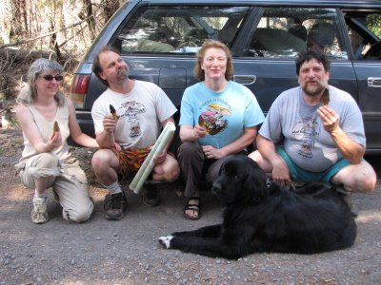
“Eastside Foray” in June 2009. Photo by: Harborseal.

Electronic delivery of The Truffler

The cost of postage keeps rising, so NATS is encouraging members to “opt-in” to the electronic-only version of The Truffler.

To “opt-in” to the electronic version, simply mark the box on the enclosed membership renewal form, or send the membership coordinator an email request to opt-out of the printed version.

When the newsletter is issued, all members will receive an email with links to The Truffler on the NATS website. The newsletter, starting with this issue, will be available in Word and PDF versions.

Save a tree, and help keep NATS’ costs under control! Thank you.
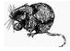

The man who knows all the forest's secrets

by Andy Parker, The Oregonian
If it weren't Lars Norgren telling the story, you'd have stopped listening long ago.
Because you assume that in recent times, no one really lived in an old school bus up near the headwaters of the South Fork of the Nehalem River in the Tillamook forest.
No one truly spent their days among some of the planet's freshest naturally occurring berries and mushrooms and fish, yet forsook it all for a daily meal of a can of Spaghetti-Os dumped between two slices of Wonder bread.
But when it comes to secrets of Oregon's forests, Norgren knows. So you drive to the shell of an old gas station on the western edge of Washington County, where he runs his long-thriving business, and you listen.

continued on page 2

During the fall of his senior year at Reed College, Norgren was already heading out to the Coast Range at least once a week to scoop up chanterelles and other mushrooms.
By the next year he was picking full-time, selling mushrooms to local restaurants and grocery stores.
In 1985 he met Walt Urwin, the Spaghetti-Os man, who knew the forest understory well enough to pick 70 pounds of mushrooms a day. Norgren quickly became Urwin's best customer, and soon created a network of local pickers, including families of Cambodian war refugees.
By the 1990s, Norgren's company, Peak Forest Fruit, was harvesting hundreds of pounds of mushrooms a day and shipping them all across the county and the world.
There were morels and porcini in the spring and early summer. Chanterelles, fist-sized lobster mushrooms, oyster mushrooms, matsutake and maitake in the late summer and fall. Truffles through the winter.
Nothing irritates Norgren more than the hodge-podge of fees for picking more than a gallon a day that can vary even within different districts of the same Oregon forest.
And you don't want to get him started about the parts of Idaho and Montana where commercial mushroom picking is no longer allowed.
“It's absurd. You can't pick mushrooms. But you can bet they still allow salvage logging.”

NATS has an HP Photosmart D7260 printer for sale: $100 or best offer. Please email Sylivia at sylviachd@q.com if interested.

continued from page 1
He happened upon the Spaghetti-Os man while foraging for mushrooms back in the mid-1980s on the front edge of a career that over the past quarter-century has made him a local legend of sorts.
When you spot Norgren among the neat stalls of berries and flowers and onions and potatoes at a local farmers’ market (McMinnville on Thursdays; Northeast Portland on Saturdays), you're not sure exactly what you've stumbled into.
In his stall sit the jewels of the forest. Luminous huckleberries gleaming like garnets. Prehistoric-looking orange lobster mushrooms the size of your hand. And of course, the golden flower of the Oregon forest – the chanterelle mushroom.
His look, intended or not, is disheveled – the clothing worn and loose below a shock of gray hair.
“You should have seen him when he was back at Reed,” says Greg Higgins, chef at The Heathman then at Higgins, who has been buying mushrooms and berries from Norgren since the 1980s.
“He would come into the restaurant wearing this old flea-bitten beaverskin top hat and a thick Norwegian sweater. I'd buy five or six hundred dollars worth of mushrooms and send him off to accounting.”
But like many top chefs across Portland, Higgins, who still goes out foraging with Norgren and plans a mushroom dinner with him every year, is a huge fan.
“We buy from him every week,” said Higgins. “He's always got fresh things that really represent an important facet of the food culture here. He's very knowledgeable.”
Norgren came by his knowledge honestly. His father, Joel, is a widely-known expert on forest soils who studied in forests around the world. Frequently, Lars tagged along.

Calendar of Events
2009 Mushroom Conference
Place: Breitenbush Hot Springs Resort
Time: October 22-26, 2009
Visit http://mushroominc.org/details.html for more info
Mt. Pisgah Mushroom Show
Place: Mt. Pisgah Arboretum, southeast Eugene
Time: Sun. Oct. 25
http://mountpisgaharboretum.org/festivals
Oregon Mycological Society Foray
Place: Rockaway Beach, Oregon
Time: Sun. Oct. 30 – Nov. 1
http://www.wildmushrooms.org/frames/oms_forays.htm
NATS November Foray
Place: Beaver Creek (South of Philomath)
Time: Sat. Nov 7
See the NATS website for more information.
NATS November Meeting
Place: Corvallis Multicultural Literacy Center
Time: Tue. Nov 10, 2009, 7:30PM
Speaker: Chris Fischer: "Brulee": the allelopathic display of Tuber melanosporum colonization. The establishment of Black truffle orchards involves planting tree seedlings that are colonized with ectomycorrhizae of Tuber melanosporumin soils receptive to both the host tree and fungus. How do growers monitor the success of the symbiosis prior to the onset of truffle production? One of the first visual indications that the truffle mycelium is proliferating in the soil is the appearance of the “brulee” or burn.I would like to share observations from some of the truly impressive burns which we have documented from both natural truffle beds as well as truffle orchards in Spain, and discuss the possible ecological implications of this allelopathic process.
NATS Annual Potluck
Place: Corvallis Senior Center 2601 NW Tyler, CVO
Time: Sat Dec 5, 2009, 6PM See below for more info.
Oregon Truffle Festival
Place: Eugene, Oregon
Time: Jan. 29 – 31, 2010
http://www.oregontrufflefestival.com/
Possible NATS Membership Fee Increase

On January 1, 2010, the annual NATS fee may increase, pending approval. This means individual membership will increase to $15.00 per annum, from $10.00. For a family, each additional family member in the household will be $10, and international membership dues will increase to $20.00.

Members who sign-up or renew before Jan. 1, 2010 will be able to renew at the old rates. Good reason to renew on time!

This proposed increase in dues was caused by the rising cost of postage, printing, and other administrative costs. However, NATS is still one of the cheapest organizations to belong to! We appreciate the support of each and every member.
Editor’s Comments

It has already started to be a good mushroom season. I’ve found large chanterelles earlier than ever. I do hope that good luck will also apply to truffles as the season progresses.

I’d like to ask folks what they’d like to see in future issues of The Truffler – more recipes, fewer recipes, more scientific stuff, pictures, whatever? Please let me know! Next newsletter will be published early January, 2010.

Jon Kenneke, Truffler Editor jon@kenneke.com
Disclaimer
The information contained in The Truffler is to be used at your own risk. NATS, Inc., its officers, editors, and members are not responsible for the use or misuse of information contained in the newsletter. If you are unsure of mushroom identification or safety, please consult an expert. It’s better to be safe than sorry!

The Truffler Recipes

Chanterelle Mousse

Iain Duncan, owner of several fine Corvallis restaurants (Le Bistro, Aqua, Terzo, and the soon-to-be-opened Flat Tail Brewery) supplied this fabulous recipe.

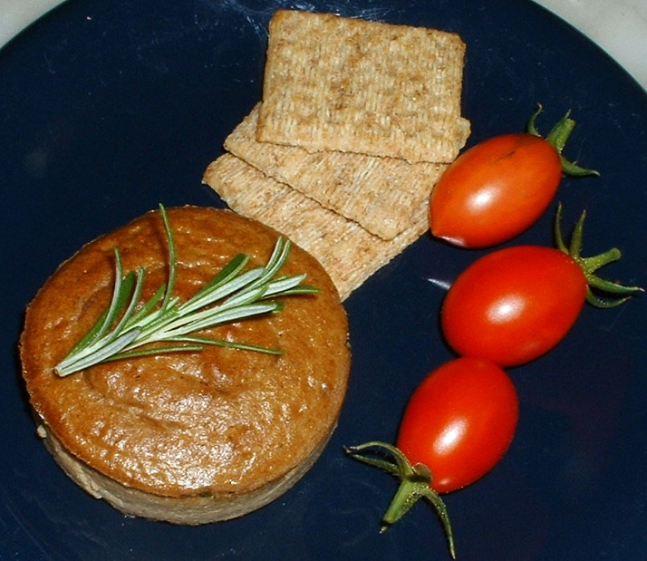
1 cup chanterelles chopped
2 Tablespoon butter
1 Tablespoon olive oil
1 small onion chopped
1 cup heavy cream
2 eggs
2 egg yolks
1 teaspoon salt
Pinch black pepper

Preheat oven to 350 degrees and butter 6 ramekins. Melt butter with oil. Add mushrooms and onion until mushrooms are soft and onions are translucent. Add cream and cook until slightly thickened. Put in blender and blend until smooth. Add eggs and yolks and continue to blend. Add salt and pepper and blend. Pour into ramekins and place ramekins in pan with hot water up to half the height of the ramekins. Put pan in the oven and cook for 40 minutes, or until a knife inserted in middle comes out clean. Photo: Jon Kenneke

Truffled Chicken

Chef and cookbook author James Peterson developed this simple version of the French classic poulet demi deuil, or chicken in half mourning. Submitted by Dennis and Norene Wedam, NATS members.
.

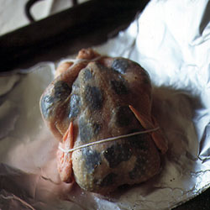
SERVES 4

1 3 1/2-lb. chicken, rinsed and dried
3-4 oz. black truffles, sliced into thin discs
Salt and freshly ground black pepper
1 clove garlic, peeled and halved lengthwise
2 tbsp. butter, softened
1 tbsp. rainwater Madeira
1 tsp. cognac

1. Working from the neck opening, with your fingers, gently pry chicken skin away from as much of the breast and legs as you can without tearing it. Slip truffle slices under skin in a single layer, covering as much flesh as possible. Truss chicken, wrap loosely in plastic, and refrigerate overnight.

2. Preheat oven to 400°. Rub chicken with salt and pepper. Rub a large piece of foil with garlic and then butter. Pour Madeira and cognac into chicken cavity and on foil. Place chicken on foil and wrap into a neat, tightly sealed package. Bake on a baking sheet for 1 hour (10 minutes longer for a large chicken). Place package on a serving platter and open at the table to allow everyone to enjoy the fragrant steam. Serve with buttered egg noodles and good crusty bread. Photo: Christopher Baker.

Preserving Truffles – Recipes and Information

Basic recipe for preserving all types of truffles:
1 part truffle, coarsely chopped
3 parts fresh lightly salted butter
Drain all free juice from the truffles (hard truffles will not tend to “weep,” though any soft truffles will); reserve juice and either salt the juice lightly to preserve or use immediately. Whip butter and truffles together by hand or in a food processor; pack tightly into a sealed jar. Do not can with heat. Make sure the top layer is entirely butter; do not allow any truffle pieces to be exposed on the surface. This product will keep in the refrigerator for up to one year in my experience, or indefinitely in the freezer, though some quality is gradually lost over time. If mold grows on the surface, scrape all traces of mold, discard mold and freeze the product.
Oil crocking recipe
Whole or cut Italian white truffles or unpeeled Perigord black truffles, brushed absolutely clean and dry. Add enough light, mild flavored oil to completely cover truffles, at least 5× volume of oil per volume of truffle in jar.
For Italian whites, use a mushroom brush, a pastry brush or soft cloth to carefully remove all dust and dirt from the surface without using any water. Cut large Italian whites into chunks no bigger than 3/4" across for best preservation. For Perigord or Chinese (hard shelled) black truffles, scrub them with a toothbrush dipped in brandy, then dry them thoroughly. Cover completely with oil (surface should be at least 2" above truffles) and shake gently to eliminate air bubbles and to be sure the truffle pieces are completely covered. Seal the jar (do not use heat, but you might use plastic wrap or nitrogen gas to eliminate oxygen contact with surface), and refrigerate. Cut truffles will keep longer in butter or oil, but will not retain as much flavor. If you wish to preserve the truffle products for the long term and allow most of its flavor to leach into the preserving agent, chop the truffle very finely and cover it completely with enough oil to stand at least several inches over the cut truffles.
Preserving hard-shelled truffles (French, Chinese and Italian black)
Peeled or unpeeled black truffles (methods will differ); butter, oil, or pure, good quality brandy, preferably alambic, 4–× volume per 1× of truffle. To preserve whole black (hard shelled) truffles, scrub clean with a toothbrush dipped in brandy and dry thoroughly. Cover completely with butter or oil, and refrigerate or freeze. They may also be peeled, chopped coarsely and mixed with butter, and the resulting product will last longer under refrigeration. Another preservation method that can be used to greatest effect and economy with the peels alone, though it can also be used on the whole or halved product, is to cover completely with a good quality brandy, preferably alambic or armagnac, and refrigerate in a sealed jar. The intensely flavored brandy can be used in sauces or sprinkled as is on a dish for flavoring. It should be cooked only long enough to eliminate the alcohol (if that is desired) or flamed, though the peels themselves can be simmered into a sauce for up to an hour. Some early French chefs also cleaned and preserved black truffles in port wine or vinegar, but I believe brandy gives a better and more consistent result for preservation, though both port wine and good wine vinegar are very fine matches for the black truffle when it is simmered in a sauce.
Notes on preservation
These notes are the result of one year's worth of truffle preservation experiments; the recipes and techniques that survived the year are listed here along with the spectacular failures. Note that all of these methods also require supplemental refrigeration; room temperature is not good for truffles in any way, shape, or form.
The following methods were tested: freezing in oil, freezing in alambic brandy and oil, crocking in cognac and oil, crocking in oil alone, storing in brandy alone, laying down in moisture-controlled sealed jars of rice or polenta, rubbing lightly with oil and/or alambic brandy and storing in rice.
Freezing truffles completely covered with oil—butter, duck fat, or reserved foie gras drippings seem to serve best to fully coat and preserve the mushrooms—has yielded excellent results for Oregon truffles, perigord and Chinese black truffles, with good product quality being maintained for up to a year. Frozen truffles are best cooked. Be sure that no truffle surface is left exposed; the mushrooms must be completely covered in fat to avoid freezer burn. And don't thaw the product before adding it to a dish; I found that frozen soft truffles turn into flavorless mush within an hour of defrosting, and the hard ones tend to dry up. Use them before you lose them.
Freezing truffles without oil is one of the spectacular failures. The product ends up dry and tasteless within days. Likewise, canning removes the majority of the flavor. I have found, in five years of searching, buying and experimenting, only one canned truffle product which I felt retained anything close to the genuine truffle aroma, a Tartuffon white truffle creme from a company in Italy. Urbani also makes an excellent white truffle cream product in a tube.
Refrigerating in brandy yields very respectable results with the hard-shelled black truffles, and poor results with most other types. Mixing a few drops of brandy in with the preserving oil before freezing again yields good results with hard shelled truffles and odd results with soft truffles. Truffled brandy is delicious to add savor to sauces or meats when added at the last minute.
Crocking in pure, unflavored oil such as grapeseed or a very light olive oil gives good results for the Italian white truffle as well as the hard shelled black truffles, and mediocre results for the Oregon soft truffles. The truffles infuse the oil with much of their aroma and taste, but I have noticed an interesting phenomenon: the oil can and does get supersaturated with the truffle aroma if you use enough truffles, at which point the truffles seem to stay much fresher and retain more of their properties. I know of no other preservation method that works well for the delicate Italian white.
Laying truffles down in a covered bed of rice or cornmeal yields good results for short term storage in the refrigerator, and also produce a delicious by-product of flavored rice or meal for risotto or polenta. This is a short term method and will not keep truffles for longer than two weeks at the maximum in reasonably good culinary condition. Some extension on this period can be achieved by scrubbing hard shelled truffles with brandy, and lightly oiling, as this inhibits mold spore growth on the outside of these truffles. This method yields mixed and uncertain results with Oregon soft truffles, and very poor results with Italian white truffles.
Cleaning and preparation
To clean and prepare truffles for storage, use a soft basting brush or mushroom brush. Carefully clean any mold and dirt off of them. Do not wash soft truffles such as the Italian white or any American soft truffles. For sturdier truffles (the hard-shelled black truffles, the perigord and Chinese), use a clean toothbrush dipped lightly in a good quality brandy (alambic works best), then dry.
If you find serious mold on a hard shelled truffle's surface, it may still be salvageable. You can (as a last resort) scrub thoroughly under running water, or with a hard bristled "truffle toothbrush" dipped in alambic brandy. If you can successfully scrub off the mold and it has not penetrated the shell, and the aroma is still good, this truffle may still be preserved either by freezing in oil or butter or for a day or so by giving it a final scrub with the toothbrush dipped in oil and burying it in cornmeal or rice in a refrigerated container. If you are unsure, slice the truffle in half and look for soft or moldy bits, and smell again for off odors. Be sure to thoroughly dry off all truffles before attempting preservation.
Partially rotted truffles are best preserved by slicing off the rotted parts, chopping the remainder coarsely and whirling it into about 3× the volume of pure, lightly salted butter, then freezing the resulting truffle butter.

From http://www.1-800-caviar.com/preserved-truffles.html

Call for Newsletter Submissions

As you probably already know, The North American Truffler is published every quarter. If you, as a member of NATS, have articles, experiences, or recipes you would like to have published in the newsletter, please submit them to the editor. His email address is: jon@kenneke.com. Any type of format is accepted.

We also appreciate photographs of NATS forays and other interesting things!

NATS Meeting Minutes and Foray Report

OCTOBER 6, 2009

Marilyn Hinds called the meeting to order. She asked everyone to introduce themselves and called it to our attention that we had a new family attending this evening. They had also attended the foray at Black Rock. David Aurora was also in attendance.

Zelda Carter reported that there is $3,338.66 in the checking account.

Marilyn reported that about 25 to 30 people attended the foray led by Loren McMahill. Truffles found were: Rhizopogon, Hymenogaster, Tuber oregonenses and Leucangium carthusianum.

The board approved the selection of Jon Kenneke as the new newsletter editor. He has come highly recommended by Matt Trappe. Jon asked the audience to submit any newsworthy items to him within the next two weeks so he can include them in the next newsletter.

The board discussed an increase in the yearly membership dues. Because our by-laws state the dues amount the board, upon Dan Luoma’s recommendation has proposed a change in the NATS by-laws. The change has to be read at three consecutive meetings culminating in a vote after the last reading. The following was read at the meeting.

Annual dues for active U.S. and foreign members of the North American Truffling Society shall be determined by the board of directors, followed by a vote of the membership attending the last reading.

Anyone paying dues before January 1, 2010 would pay the old rate. After January 1, the dues would be: Individual $15, additional family member living at the same address $10. Foreign membership would be $20.

Marilyn announced the upcoming mushroom shows. Yachats is October 16, 17 and 18. Sylvia Donovan and Mysti will work that show with Betty Orner and Sarah Uebel helping and if asked, Loren McMahill will also help.

OMS show is the 18th of October. Marilyn will contact Adrian Beyerle to see if he can represent NATS at the show.

The Mt. Pisgah show will be October 25th. Marilyn Hinds, Sylvia Donovan and Sarah Uebel will work the show as well as Loren McMahill if needed.

Marilyn asked for input on NATS having a table at the Truffle Festival in January of 2010. She wondered if it was to our advantage to be there. Last year only two members were given free passes. All others had to pay to attend. Our revenue last year from the event was down considerably.

Joyce Eberhart passed around drawings by Jillian Haas who has re-drawn the tree with roots underground and truffles attached to the roots. Mysti Weber also passed around drawings for possible new tee shirt designs by the same artist. Mysti will contact the printer to see what the cost would be for the new designs.

Marilyn announced that the December potluck will be December 5th. Sylvia is in charge of the event and asked for volunteers to contact her. She needs centerpieces and help setting up and taking down the tables and chairs.

The Statesman Journal featured an article on the Willamette Mushroom Society of which Helen Yahiku is a member. The article generated a lot of interest and Jim Trappe wondered if NATS could also get some publicity.

Joyce Eberhart announced that next month’s speaker will be Chris Fischer from Spain and Jim Trappe will be the speaker at the potluck.

Joyce introduced our speaker for the evening, her husband, Dan Luoma. Together, they presented an update to a book (in CD-ROM format) on truffle identification by Kathy Jacobs, Dan Luoma, Jim Trappe, Joyce Eberhart, Efren Cazares, and Mike Castellano.

The Mushroom Year in Pictures

Not a good truffle year for me, but enjoy the look back at my other finds. Please be sure the visit the NATS website to see the newsletter in color. All photos by Jon Kenneke

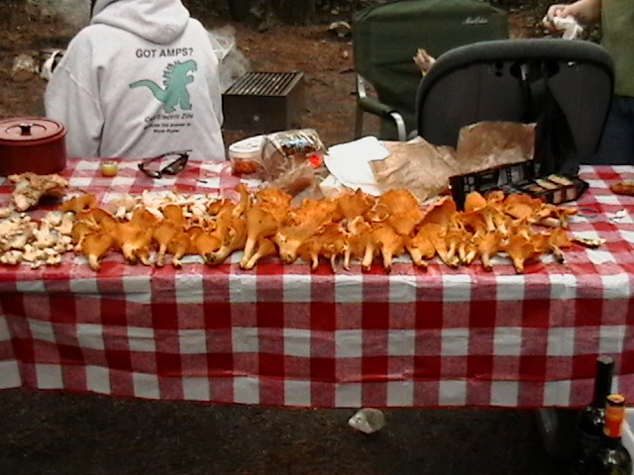
← Chanterelles found near Florence, OR

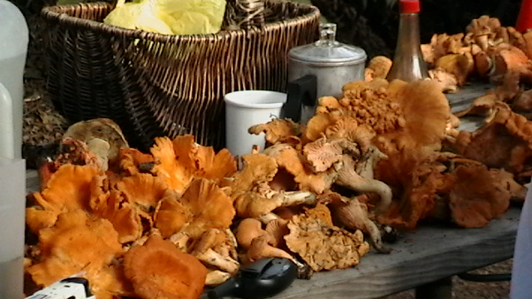

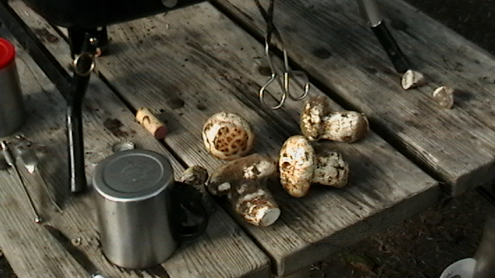
Matsutakes Anyone? →
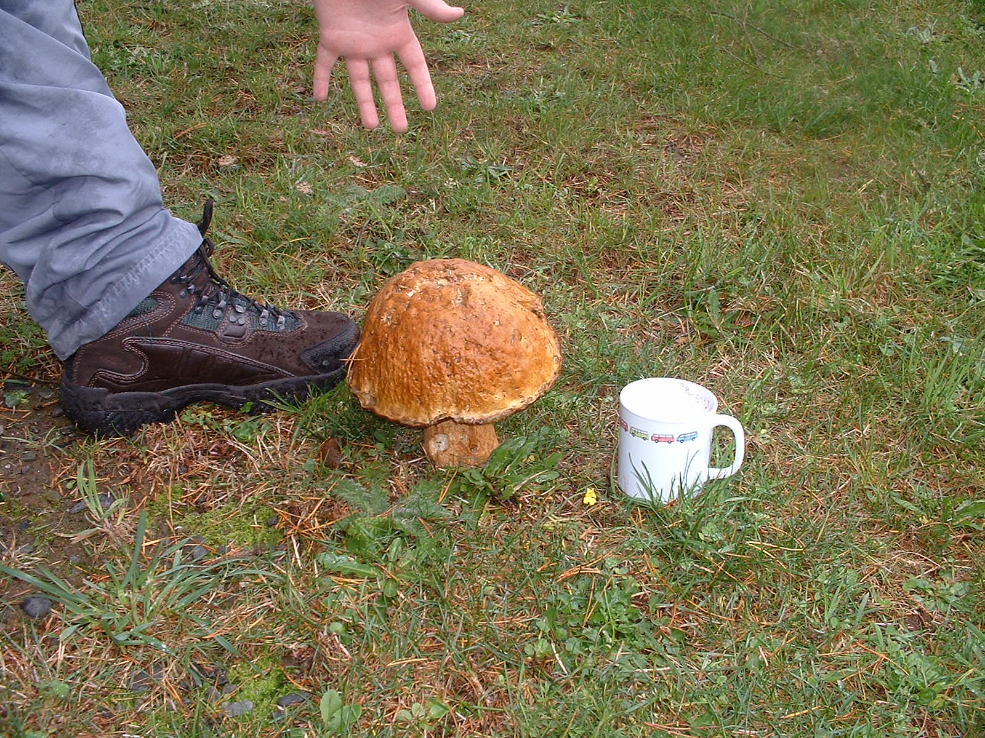

← A Bolete growing in the middle of a field at a campground.

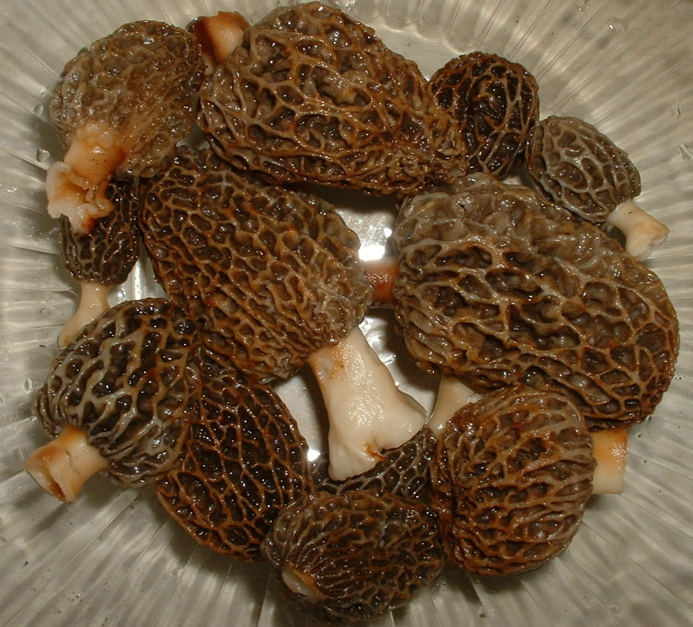
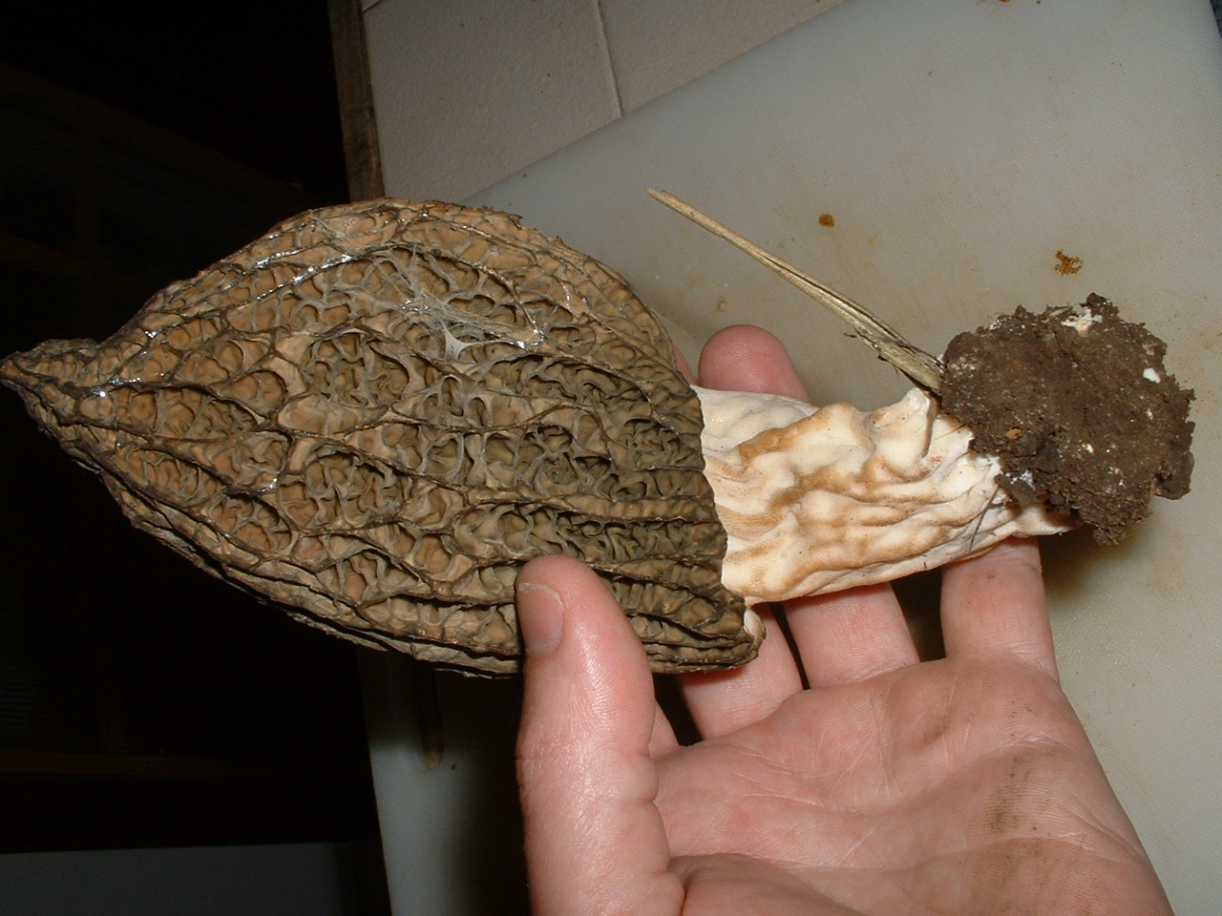
← Morels from my backyard.

A Few Truffle-Oriented Frequently Asked Questions

From the NATS web site

What are truffles?
Truffles are hypogeous (underground) versions of mushrooms. They don't form a prominent stem and their spore-bearing surfaces are enclosed. They rely on animals eating them (mycophagy) to distribute their spores, instead of air currents like mushrooms. Truffles resemble small potatoes, and often between the size of a marble and a golf ball (see the photo gallery). There are hundreds of different kinds of truffles, and while none are known to be poisonous, only a few of them are considered to be delicacies by humans. Truffles (and mushrooms) are only the "fruit" of the fungus (like an apple to an apple tree); the main perennial fungal body exists as a web of filamentous hyphae in the soil. All of the truffle fungi form mycorrhizae with the roots of trees, and are essential to the trees' ability to acquire nutrients. The belowground fruiting habit of truffles is thought to be an adaptation to forest fires or dry or frosty periods, in which aboveground mushrooms are more vulnerable. Oregon State University Extension has published a nice overview of truffles, "An Oregon Garden Guide to Truffles."
What is mycophagy?
As most truffles never break the surface of the soil, they must rely on animals to eat them and distribute the spores in their scats. The word "mycophagy" comes from the Greek words "mykes" (fungus) + "phagein" (to eat). Some animals, like the red-backed vole, eat truffles almost exclusively. In order to be located by hungry critters, truffles have evolved strong scents that, as they mature, can be detected from a distance by a suitably sensitive nose. Depending on the species of truffle, to humans these scents can be pungent, fruity, unpleasant, or delectable.
What are mycorrhizae?
Mycorrhizae are a symbiotic (mutually beneficial) association between some kinds of fungi and plants. The word "mycorrhizae" comes from the Greek words "mykes" (fungus) + "rhiza" (root). Fungal filaments (hyphae) are much more efficient at extracting water and nutrients from the soil than root hairs - it has been reported that there are as much as 100 meters of fungal hyphae in one teaspoon of healthy forest soil. The fungal hyphae not only permeate the soil, they penetrate the root cells of plants and facilitate a nutrient exchange where the host plant gets needed nutrients from the soil via the fungi, and the fungi (which cannot perform photosynthesis) get their needed sugars from the host plant. Many plants will not grow well at all unless they have mycorrhizal fungi on their roots helping them get nutrients.

What is the role of truffles in ecosystems?
Truffles (and mushrooms) are the "fruit" of underground webs of fungi. The fungi of all truffles (and many mushrooms) are mycorrhizal. Mycorrhizae are essential in assisting trees obtain nutrients and water from the soil - without mycorrhizae we would not have forests as we know them today. Truffles are also an important part of the food chain via mycophagy. For example, flying squirrels rely on truffles for food, and spotted owls rely on squirrels for food. In turn, the fungi rely on the squirrels (and owls!) for spore distribution, the trees rely on the fungi for nutrient acquisition, the fungi rely on the trees for energy (sugars from photosynthesis), and the owls and squirrels rely on the trees for habitat.

What are "True" vs. "False" truffles?
In Europe, the term "truffle" in the very strictest ("true") sense has historically only referred to those hypogeous (belowground) fungi that were gourmet edibles, primarily in the genus Tuber. Tubers are members of a larger grouping of fungi called Ascomycetes. For some folks, only Tubers and their close relatives are considered "true truffles" (all others being "false truffles"), and for other folks all hypogeous Ascomycetes (irrespective of culinary qualities) are called "true truffles". However, there are many, many other perfectly nice species of hypogeous fungi, both Ascomycetes and Basidiomycetes, that are not particularly prized as food outside the squirrel community. Nowadays many folks have discarded the "true truffle" and "false truffle" distinctions for a more egalitarian nomenclature, and are quite comfortable simply calling all hypogeous fungi TRUFFLES.
North American Truffling Society (NATS)  P.O. Box 296  Corvallis, OR 97339  www.natruffling.org |  | Non Profit Org  U.S. Postage  Paid  Corvallis, OR.  Permit No. 104

Field Data \Truffle ID Cards:

Collector______________________ Date___________  Location______________________________________  _____________________________________________  T/R/S or  County__________ Lat/Long_____________________  Elev________ Aspect: N NE E SE S SW W NW  Growing On/In: Moss Mineral Rotten Needle  (Circle one or more) Soil Wood Litter  Other/Notes___________________________________  Overstory Trees_______________________________  Understory Shrubs_____________________________  Fresh Notes (color, odor, etc.):___________________  ____________________________________________ |  | Collector______________________ Date___________  Location______________________________________  _____________________________________________  T/R/S or  County__________ Lat/Long_____________________  Elev________ Aspect: N NE E SE S SW W NW  Growing On/In: Moss Mineral Rotten Needle  (Circle one or more) Soil Wood Litter  Other/Notes___________________________________  Overstory Trees_______________________________  Understory Shrubs_____________________________  Fresh Notes (color, odor, etc.):___________________  ____________________________________________

