Inside This Issue
1 | Outgoing Editor’s Comments
3 | Event Calendar
3 | Meeting Minutes and Foray Report
4 | Editor’s Comments
6 | Ethical Guide to Truffle Harvesting

The North American Truffler
Journal of the North American Truffling Society

Volume 28, Issue 1 Summer 2009

. 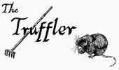Hi all, its your former newsletter editor Loren McMahill, I just wanted to thank NATS for the opportunity to put together "The Truffler" for the past couple of years, its been a lot of fun and has greatly increased my knowledge of truffles. Due to various reasons I haven't had time to get the issues out in a timely manner so I thought it would be best to hand off the job to someone who can. Fortunately Jon Kenneke has stepped up to the task and taken over the reigns. I can't wait to see what Jon has in store for us. The newsletter is an important part of NATS and one of the few ways we can communicate with the general membership.

Being the NATS newsletter editor has been great fun, becoming a proxy board member was unexpected, but it allowed me to meet people like Jim Trappe, to me nearly a folk hero. Certainly one of the greats in the world of mycology and "The Truffle Master". And of course "The prodigal son" Matt Trappe. Yet another person who I had only read about when I started, Matt is always out there to lead and identify our finds. The Trappe’s expertise in and participation in NATS is huge. I'm thankful that they make themselves available for NATS. Recently one of our board
Members, Dave Pilz moved down south to California for some gainful employment. (Which everyone is finding tough these days) Dave was the membership coordinator, as well as co-author of some great publications on morels and chanterelles, and was extremely diligent with club matters,
always willing to put in some extra time. How can you not miss a guy like that on the board? I wish Dave the best of luck with his new job, and want to give him a shout out for his contributions to NATS.

Marilyn, Zelda, Pat, Sylvia, Mysti, the club wouldn't function without you. You all keep everything together. Without that, we wouldn't have NATS. Your contributions have been invaluable.

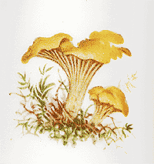
How Cantharellus formosus Became the Oregon State Mushroom
It was one of the newest Oregon Mycological Society members who decided Oregon needed a state mushroom. Just after the latest taxonomy declared the West Coast to have an unnamed Cantharellus species, Dr. Kevin Winthrop and his legislator friend, Chris Beck, put their heads together to start the process for HJR 68. What a campaign was waged!
Enlisting Jack Czarnecki, famed mushroom chef of Joel Palmer House fame, Lorelei Norvell, OMS's Ph.D mycologist, and Maggie Rogers, co-editor, Mushroom the Journal of Wild Mushrooming, the group met

continued on page 2
continued on page 2

And of course Helen for all the delicious treats she brings to the meetings.

I'd like to thank everyone and I feel honored to be a part of NATS. While I'm no longer going to produce the newsletter, I'll still be the NATS librarian. And we have quite a library.
I'm working on making it more available to members. Some things we'll be able to scan and send as a pdf or jpg for your pleasure. Others you may have to send for, depending on size. Hopefully we'll have some of it online in the future. I'll have more information available on how to use the NATS library in an upcoming newsletter.

Cheers everyone, and see you in October

-Loren

lorenmcmahill@yahoo.com

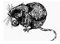

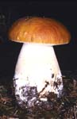

Mushrooming Arts & Crafts: Resources, Readings and Techniques

Instructor: Maggie Rogers
Date: Oct. 23 (evening), Oct. 24 and 25, 2009
Location: Deer Creek Center, Siskiyou Field Institute
Kid Friendly 12+

Good taste in fungus isn’t all about consumption. Perfect for beginners and those with an intermediate mushroom understanding, join Maggie Rogers to learn mycological language and identification skills, then journey into a new world of mushroom arts and crafts. Make a design using spores and use your new awareness to draw and paint mushrooms with greater insight. For more information, surf to http://thesfi.org/Page.asp?NavID=456

continued from page 1
twice with legislators in early-morning hearings. Dr. Winthrop contacted some of his colleagues to call and urge passage of the bill. By the second hearing, we had our charts and factoids together. Photographs, a review of the OMS Chanterelle Study, market value of the harvest, nutrient values -- and recipes! "The Pacific Golden Chanterelle, unique in Oregon's wild mushroom harvest: Cantharellus formosus, formerly thought to be Cantharellus cibarius."
From then on, it was all good fun. We had no idea five out of six legislators could have such a good time talking mushrooms before their next 5 p.m. hearing. They put a "do pass" recommendation on it, and two senators volunteered to bipartisan support on the floor. Chairman Charles Starr enjoyed it the most. When the other legislators urged moving on to "more important things," he demurred, saying, "These people came all this way from Portland, and I think they have some interesting things to share with us." So we did. Our best line, in spite of the media, became "The chanterelle's harvest is a peaceful harvest." The headline in the June 22, 1999 Oregonian read: "Fungi move faster than fiscal issues in Capitol." A tongue-in-cheek letter to the editor of the Statesman Journal was headed, "Mushroom measure wastes legislative time," and ended, "I will rise each morning with a song of mushroom praise warming my heart." By one vote, the bill passed.
-From the Oregon Mycological Society Website: http://www.wildmushrooms.org/
Continued from page 1

Calendar of Events
There will be no meetings or forays in July, August, and September.
October NATS Foray
Place: TBA
Time: Saturday, Oct. 3, 10am.
Check website for more information.
october NATS meeting
Place: Corvallis Multicultural Literacy Center at 128 SW 9th street in Corvallis
Time: Tuesday, Oct. 6, 7:30pm
Speaker TBA.
2009 Mushroom Conference
Place: Breitenbush Hot Springs Resort
Time: October 22-26, 2009
Visit http://mushroominc.org/details.html for more information.
Yachats Mushroom Festival
Place: Yachats, Oregon
Time: Oct 16-18, 2009
For more information, visit: http://www.yachats.org/events.html
Mt. Pisgah Mushroom Show
Place: Mt. Pisgah Arboretum, southeast Eugene
Time: Sun. Oct. 25
For more information, visit: http://mountpisgaharboretum.org/festivals

What to do with the Truffle you can’t identify?

You can send them in dried to the Oregon State University Forestry Sciences Lab. Simply fill out a field data card (see last newsletter page), and send the truffle and data card to:

Forestry Sciences Lab
Attn: Matt Trappe
3200 Jefferson Way - 020
Corvallis, OR 97331
The field data card NATS uses notes significant characteristics of the habitat in which a truffle is collected. It's mostly self-explanatory; the "T/R/S or Lat/Long" field is for Township/Range/Section or GPS data if available, and the "Aspect" is the direction a slope is facing (leave blank if flat).
Again, please dry specimens thoroughly before sending them; specimens that arrive moldy and smelly will be discarded! If you would like to be notified of the identification, you must include your email address or a self-addressed stamped postcard with your collection. Collections will be published in the NATS newsletter.
* If you don't have a food dehydrator, truffles can be dried by leaving them in the refrigerator in a loosely closed paper bag for a couple of days. They'll dry faster if you cut them in half first.

MINUTES OF THE NORTH AMERICAN TRUFFLING SOCIETY – JUNE 9, 2009

President, Marilyn Hinds brought the meeting to order. Treasurer, Zelda Carter reported that there was at present, $4,608.24 in the checking account.

Matt Trappe reported on the June 6, 2009 foray to the Beaver Creek area, south of Philomath. Ten people attended the foray including people who were attending for the first time. The area had 50 to 60 year old Douglas fir along with some alder. Matt was surprised that no Hymenogaster truffles were found this time but some of the neat things found were Genabea cerebriformis, Alpova trappei and Balsamia nigra. One specimen was turned over to Castellano for identification but Matt didn’t have that information yet. He reported that the first fall foray in October has not been set yet but the November foray might be back at the Beaver Creek area. There were some interesting attendees, including two who invited NATS to foray on property within a gated community. Later they revealed that this was a nudist community and also invited anyone who would like to come to the area on July 11th to come and take part in what they hoped would be a world record for “Skinny Dipping”.

Marilyn asked what the progress was on the handout “guide to truffling”. Sylvia reported that it was complete and could be downloaded off the NATS web site. For those not familiar with the handout, Sylvia told that it outlined courtesy in the forest including placing the duff back as found and picking only ripe truffles.

Marilyn asked if we needed to print more specimen cards to record finds. Matt said that if the specimens were found during a foray, he would have all the information needed. If people found truffles on their own, they can download the card from the web and after drying the truffle, mail it in to NATS. [Ed note: field cards and instructions are reprinted in this edition of the newsletter]

Sylvia wanted everyone to know that both she and Marilyn had found a good quantify of “Earth Star” and they were turned in to the lab to be sent back East for a research project. The possibility of the earth stars being used for patients with T.B. or Parkinson’s disease might create a viable market for collecting. Also, OSU, as well as NATS would get a percentage if any profit was made from this find.

Marilyn reported that we should probably purchase more tee shirts for the fall shows as well as truffle guides and the book, Trees, Truffles and Mushrooms. She was told to go ahead and order the books now as well as the tee shirts. Joyce has a friend who is an accomplished artist and she has volunteered to help with a new design but Matt felt that there was not enough time to get a new design made up in time to have tee shirts for the fall mushroom shows. Joyce, Misty and Betty have volunteered to be a committee to follow up on the new design.

Marilyn reported that Loren no longer has time to be editor and asked if someone would like to take over that job. Matt Trappe said he was thinking about doing it. Also, Pat Rawlinson was asked to send out an email to members to see if a volunteer might be interested in that position.

Joyce introduced our speaker, Dr. David Hughes from the University of Exeter, UK. He is a researcher on fungal parasites of insects and presented his recent work, “Zombie ants: the fine detailed manipulation of ant behavior by Ophiocordyceps unilateralis. David was a very informative, well educated speaker and well received.
The meeting was adjourned and refreshments provided by Marilyn were served. Her lemon bars were really wonderful!

Editor’s Comments

Jon Kenneke, Truffler Editor jon@kenneke.com

This is my first issue as editor of the Truffler, so please bear with me. This issue, I’ll introduce myself to the members that don’t know me, and share some of my mycological interests.

I’ve been interested in Mushrooms for quite a long time, but only got serious about my interests four years ago. This started with a productive NATS foray, and some major identification instruction from a good friend. I quickly found that hunting for Chanterelles, Hedgehogs, Oyster mushrooms, Porcinis and Morels was fun and tasty. Not to forget Truffles and Lobster mushrooms. I’m lucky enough to own property on the southern Oregon coast within walking distance to some of the best foray territory in Oregon. Any guess as to where I spend significant time in the fall?

Last fall, I attended a Paul Stamets (of Mycelium Running fame, among other books) cultivation seminar. Here, I learned laboratory cultivation techniques, along with a wealth of other information. Upon return from this seminar, I set up a small home lab in a spare walk-in closet. After experimenting with propagating Oyster and Morel mycelium, I’m now attempting to culture Leucangium carthusiana, with no success yet.

In June, I was at yet another Stamets seminar. This time, the focus was using mushrooms in ecological restoration projects. I was very impressed with the outcome of a project using Pleurotus ostreatus to remove hydrocarbons from the soil. Pleurotus is also quite effecting in filtering E. Coli from water. I’ll share more about these subjects in upcoming newsletters.

Finally, there’s not a bunch of truffle specific material in this edition, but that’ll change in the fall. I look forward to being more involved with NATS as newsletter editor.

Recipes

The editor is lucky to know several of the top Chefs in the Albany/Corvallis area. So, each issue will feature a recipe from a local restaurant, as well as friends and members’ recipes.

Since the Pacific Northwest is at the beginning of the Chanterelle and Hedgehog season, I’ll share a couple of recipes for those mushrooms.

This first recipe is from a good friend, Gerry Wilson of Eugene, OR. This marinade goes great with early season Chanterelle and Hedgehog “buttons”. It’s also great with slices of Porcini. And, it would be a crime if I didn’t suggest using this marinade with Asparagus and Zucchini or even lamb chops.

Mushroom/Vegetable Marinade (aka Gerrinade)
3/4 C Olive Oil
1/4 C Balsamic Vinegar
1 C Finely Chopped Onion
1/2 tsp Black Pepper
4 Cloves Garlic, crushed
3 Tbs. Grey Poupon Dijon Mustard
1 tsp Basil
1 tsp Sea Salt
1 tsp Oregano
1/4 tsp Anise Seed
Simply put the marinade in a zip-lock plastic bag, and add mushrooms and/or vegetables. Put in a refrigerator at least 2 hours, overnight preferably, and grill.

Hedgehog Hedgehogs

This recipe is from another friend, Matt Bennett, the chef at Sybaris Bistro in Albany, OR. These make great appetizers, especially with kids. These are essentially meatballs that are shaped like little hedgehogs (the animal), that are topped with mashed potatoes to give a spiky appearance.

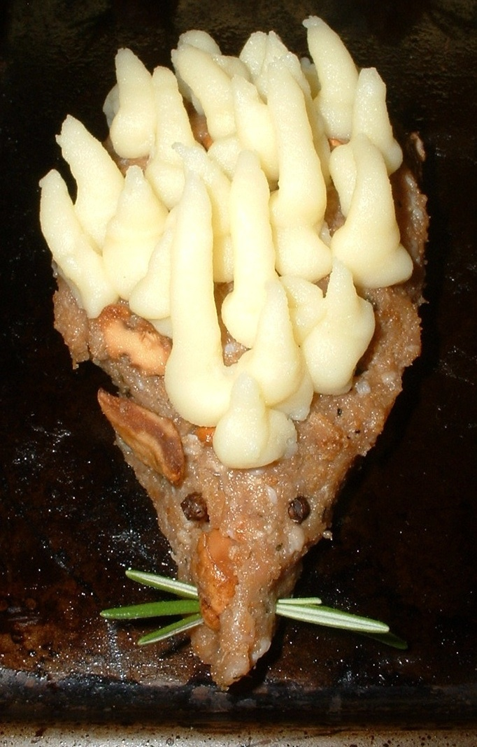
1 Lb. chopped Hedgehog mushroom, lightly fried in 1 Tbs. oil
1 Lb. ground turkey or pork (don’t use lean meat!)
½ Cup Bread Crumbs
2 Eggs
2 Egg yolks
2 Tbs. milk
Whole Peppercorns
Salt and pepper to taste
Mashed Potatoes
Your favorite gravy

Reserve a small amount of fried hedgehogs for serving. Mix the remaining fried and cooled Hedgehogs with the turkey, bread crumbs, milk, and the two eggs. Add salt and pepper to taste. Shape the meat mixture into teardrop shapes to form the head of the hedgehog. Mix the egg yolks to the already prepared mashed potatoes. Using a piping bag, or a spoon, cover the teardrop meat shapes with the mashed potato mixture, forming spikes to look like a hedgehog. Use peppercorns to form the eyes. Rosemary could be used for whiskers. Bake 20 minutes at 400 degrees F. Transfer to serving plates, and add some of the reserved hedgehog mushrooms, and cover with gravy. Serve and enjoy.

ETHICAL, SUSTAINABLE, AND COMMON SENSE GUIDE TO HARVESTING TRUFFLES

The raking method:
Raking can damage tree roots, truffle mycelium, and the local environment. Exposing tree roots to the surface can damage stability, slow their growth, expose them to disease, or even kill seedlings. Typically many truffles grow between the duff (decomposing forest litter) and the mineral soil. It’s not usually necessary to disturb the tree root system by digging more than about 2 inches into the mineral soil. Replacing the duff and disturbed soil is crucial to maintaining healthy trees and truffle patches.
When raking for truffles, it’s a good idea to leave a good portion of the ground around the tree undisturbed so that the truffles can continue to propagate naturally. Removal of the undergrowth flora from sloped areas by raking can cause devastating erosion and pollution of streams from soil and humus runoff.

Truffle Dogs
The best way to find mature truffles is by use of a trained truffle dog. More and more truffle hunters are replacing their rakes with truffle dogs, which detect only the truffles mature enough to produce a strong fragrance. We encourage acquiring and training a dog for truffle hunting. Advice on how to do this can be found by Googling “Training a truffle dog” on the internet, where you will find a good variety of websites on that topic. Use of a trained dog minimizes the damage caused by raking and leaves the immature truffles in the soil to continue the maturation process.

REPLACING THE FOREST SOIL AND DUFF after raking an area is probably the single most important thing to remember when truffling.

Truffle Ripeness:
A “ripe” truffle is one that develops the characteristic odors of its species that we humans find to our liking. In order to develop its amazing aromas, any truffle must first be well matured.
Therefore, when truffling, remember that immature truffles have little value. Harvesting immature specimens deprives one of enjoying these unique and fantastic wild edibles. Removing the immature truffles from their connection with the tree also ends the process of propagation.

Tuber oregonense (“Oregon White Truffle”):
Distribution: Northern California to Northern Washington west of the Cascade Range from sea level to about 2000 feet.
Description Surface white in youth, soon becoming mottled with brown to orange brown or reddish brown blotches and furrows with minute pubescence; at full maturity often reddish brown overall and/or with areas where the brown interior color appears to show through the peridium, as if a bruise. Interior firm, white when immature, brown with white marbling when mature.
Odor: “truffly, a complex of garlic, spices, cheese, nuttiness and indefinable other essences.”
Season when mature: December through February, depending on weather.

Tuber gibbosum (“Oregon Spring Truffle”):
Distribution: Northern California to southern British Columbia west of the Cascade Range from sea level to about 2000 feet.
Description: Surface olive to brownish yellow with some brown mottling, smooth but with whitish, minutely pubescent furrows. Interior firm, white when immature, grayish-brown with white marbling when mature. Marbling is finer- than in Tuber oregonense.
Odor: Truffly, a complex of garlic, spices, cheese, and indefinable other essences, distinctly more “garlicky” than Tuber oregonense.
Season when mature: Late April through early July, depending on weather.

Leucangium carthusianum (“Oregon Black Truffle”):
Distribution: Western Oregon and southwestern Washington, mostly in the Coast Ranges and western Cascade foothills.
Description: Peridium charcoal black and usually warty, but sometimes nearly smooth. Interior solid and firm, with gray pockets of spore–bearing tissue separated by white veins. Can reach several inches in diameter.
Odor: Pleasant and fruity (most often resembling pineapple) in youth, becoming increasingly pungent and earthy with age.
Season when mature: November through March.

These and other species are described in more detail and illustrated in A Field Guide to North American Truffles by M.J. Trappe, F. Evans, and J.M. Trappe, 2007. Ten Speed Press, Berkley, CA

IN REVIEW:

- Be sure you have permission from the land owners, or the proper permit in state and national forest lands.

- Be respectful of private property and public lands.

- REPLACE THE SOIL AND DUFF!

- Only harvest mature truffles, if the truffles are not mature move to another area or come back a few weeks later.

Be sure of your identification. The truffles listed above will be firm when you squeeze them, not soft and spongy. If enough pressure is applied they will break apart rather than compress. Knick them or cut them in half if necessary to determine type and ripeness. No truffles are known to be poisonous, but mushroom eggs can be seriously toxic and can fool someone who doesn’t have much experience. If you’re unsure of what you have, do not consume it. Check it out in the field guide noted above or ask an expert or someone knowledgeable on truffles.

Good luck with your truffling and Bon Appétit. And don’t forget to always REPLACE YOUR SOIL AND DUFF and ONLY HARVEST MATURE TRUFFLES.

-From the NATS website: http://www.nattruffling.org

Call for Newsletter Submissions

As you probably already know, The North American Truffler is published every quarter. If you, as a member of NATS have articles, experiences, or recipes you would like to have published in the newsletter, please submit them to the editor. His email address is: jon@kenneke.com. Any type of format is accepted.

Some Editor Selected Publications

Below are some publications that the editor has recently read. All except Diversity are available from Amazon.com and other booksellers.

Diversity, Ecology, and Conservation of Truffle Fungi in Forest of the Pacific Northwest by Trappe et al. USDA Forest Service Pacific Northwest Research Station. This publication is available in print and through the USDA website as a free download. The print version includes extra pictures and information on a CDROM.

Taming the Truffle by Hall, Brown, and Zambonnelli. Timber Press. Interesting information about Truffle history and cultivation practices.

Mycelium Running by Stamets, second edition. Ten Speed Press. “Mycorestoration” information aplenty.

Field Guide to North American Truffles by Trappe, Evans and Trappe. Ten Speed Press. This is a must-have book.

Field Data \Truffle ID Cards (see article):

Collector______________________ Date___________  Location______________________________________  _____________________________________________  T/R/S or  County__________ Lat/Long_____________________  Elev________ Aspect: N NE E SE S SW W NW  Growing On/In: Moss Mineral Rotten Needle  (Circle one or more) Soil Wood Litter  Other/Notes___________________________________  Overstory Trees_______________________________  Understory Shrubs_____________________________  Fresh Notes (color, odor, etc.):___________________  ____________________________________________ |  | Collector______________________ Date___________  Location______________________________________  _____________________________________________  T/R/S or  County__________ Lat/Long_____________________  Elev________ Aspect: N NE E SE S SW W NW  Growing On/In: Moss Mineral Rotten Needle  (Circle one or more) Soil Wood Litter  Other/Notes___________________________________  Overstory Trees_______________________________  Understory Shrubs_____________________________  Fresh Notes (color, odor, etc.):___________________  ____________________________________________

Non Profit Org
U.S. Postage
Paid
Corvallis, OR.
Permit No. 104

