Inside This Issue
1 | The Fourth Annual Oregon Truffle Festival
7 | Microscopy of a Tuber gibbosum
8 | Part 2 Microscopy of a Tuber gibbosum / Editorial
9 | Green Mycology: Fungus Naturally Synthesizes Diesel
11 | Minutes of The NATS Meetings October / November

The North American Truffler
Journal of the North American Truffling Society

Volume 27, Issue 2 November/December 2008

2009 OREGON TRUFFLE FESTIVAL
January 30th - February 1st
The Oregon Truffle Festival offers a multitude of exciting ways to participate, for a few hours or a full weekend.
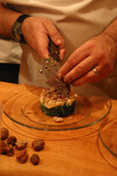
photo by Georgia Freedman
Since its inception, workshops, packages and the Grand Truffle Dinner have sold out quickly, so early registration is recommended. All events are located in and around Eugene, Oregon.
Why an Oregon Truffle Festival?
In the rarified world of truffles, Oregon is known as the premier center of research and expertise outside of Europe. A lineage of eminent scientists has maintained that standing for almost a century, and continues to hold it to this day. Oregon is also blessed with an abundance of wild truffles with culinary qualities equal to those of Europe,

French resort to test-tube truffles
Black truffles, emblem of France's gastronomic exceptionalism, could soon start life in a laboratory instead of under the roots of ageing oak and hazelnut trees.
French scientists are planning to clone Périgord truffles, the pungent fungi known to connoisseurs as "black diamonds" and which can fetch up to €1,000 ($1,267, £860) a kilo.
To mark the start of the truffle season, the French region of Corrèze is to sign an accord today for a three-year project with Delpeyrat, which has been making truffle conserves since the 19th century, and STEF-TFE, a food transport company.
The goal is to unlock the secrets of what makes the black truffle so special - the soil, climate or trees - and, it is hoped, revive an endangered industry by producing a more consistent crop.

The project will involve culturing cloned truffles together with baby trees in test tubes until they form their crucial symbiotic relationship - a process that can take a year. Once established, pairs will be planted out to mature naturally.

continued on page 2
continued on page 6
continued from page 1

and as with French grapes, Oregon has the perfect climate for cultivation of the renowned French truffles. As the ultimate culinary delicacies, truffles are emblematic of the good life in every region where they grow, and in Oregon they are complemented by our wealth of other wild and cultivated gourmet foods, outstanding Oregon wines, and an increasing number of extraordinarily talented and award winning chefs.
Despite Oregon’s long history of truffle research, its truffle industry is young and undiscovered. The few sources for wild truffles are avidly sought and jealously protected by harvesters who sell the truffles quietly here and there throughout the country. Secrecy pervades the world of truffles and is a part of their mystique, but it has not served Oregon’s truffles well, as secrecy precludes development of the knowledge necessary to bring the real potential of the Oregon truffles to market. Simple details like how to choose and handle a truffle to tease out its grandeur are known to only a few harvesters and chefs. As a result, Oregon truffles have not received the recognition that those who have experienced their essential magnificence know they deserve.
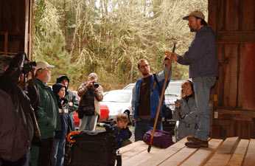
photo by Georgia Freedman
Some of us in Oregon’s nascent truffle industry decided we needed to change that. Our native truffles deserve to be celebrated as the delicacies that they are, at the same time the ground is prepared for growing a domestic supply of the illustrious French and Italian truffles. Our scientific tradition, our wealth of native truffles, and the advancement of technology and science around cultivating the European truffles have reached a confluence in Oregon, placing us at the forefront of the burgeoning truffle industry in North America. The best way to experience this phenomenon is to attend the Oregon Truffle Festival - designed to support those interested in establishing successful truffieres, while celebrating the Oregon truffles’ earthy elegance.
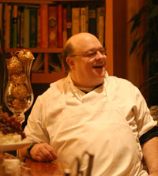
photo by Georgia Freedman

The Oregon Truffle Festival is proud to present a wonderful cast of chefs this year including Vitaly Paley, Caprial and John, and Jack Czarnecki who all doing cooking classes, Phillippe Boulot and Cathy Whims are doing the Villa Evening, and Winery lunch respectively, and the Grand Dinner features Portland's "Young Turks", with many of Portland's best restaurants featured.

There will be many other speakers on topics such as a “Truffle Cultivation” seminar, The Truffle Growers Forum, and lectures during the truffle market place which hosts a variety of truffle related topics.
Including “Tales from the Truffle Zone” presented by “The Ph.D. s’ Trappe” James and Matt Trappe and founding NATS member Frank Evans, Authors of “The Field Guide to North American Truffles”.

Tickets & Packages for the Oregon Truffle Festival 2009

Grand Truffle Dinner - $160
Saturday, January 31, 2009
Semi-formal attire please.
Advance sales only; no tickets will be sold at the door.

Grand Truffle Dinner: $160.00 ea.

2009 Truffle Cultivation Seminar - Friday and Saturday Only
The Truffle Cultivation Seminar is one’s entry point into the current science and methods of truffle farming, covering climates, soils, orchard establishment, orchard management, dog training and harvest.

Truffle Cultivation Seminar: $600 ea.

2009 Truffle Growers Forum - Friday and Saturday Only
The Truffle Growers Forum serves as an annual gathering and focal point for the International truffle industry allowing growers, purveyors, researchers and others interested in the field to catch up with current events, engage with the experts and make contacts within the industry.

Truffle Growers’ Forum: $600 ea.

Package One: $475.00 per person
Includes:
- Opening Reception - Friday
- Multiple course Truffle Dinner at festival restaurants - Friday
- Winery lunch with truffle cooking demonstration - Saturday
- Truffle Hunting Foray - Saturday
- Truffle Dog Demonstration - Saturday
- Grand Truffle Dinner - Saturday
- Sunday Breakfast
- Admission to the Oregon Truffle Marketplace - Sunday

Package One: $475.00 ea.

Package Two: $575.00 per person
Includes: All Package One offerings, but instead of a restaurant dinner on Friday, Package Two guests will enjoy multi-course, truffle dinner with wine pairings at Pfeiffer Vineyards with guest chef Philippe Boulot, James Beard award winning chef from the Heathman Restaurant and Bar in Portland. Hosted by Danuta and Robin Pfeiffer, Villa Evening is limited to 26 guests and sells out every year, so we recommend registering quickly for this elegant offering.
- Opening Reception - Friday
- Villa Evening at Pfeiffer Vineyards
- Winery lunch with truffle cooking demonstration - Saturday
- Truffle Hunting Foray - Saturday
- Truffle Dog Demonstration - Saturday
- Grand Truffle Dinner - Saturday
- Sunday Breakfast
- Admission to the Oregon Truffle Marketplace – Sunday
Package Two: $575.00 ea.

NEW IN 2009
Package Three: $625.00 per person
Includes: All Package One offerings, but instead of a restaurant dinner on Friday, Package Three guests will join Marche Executive Chef Rocky Maselli and James Beard Award-Winning chef Vitaly Paley and his wife Kimberly for a hands-on truffle cooking class in the kitchen at Marche Provisions. The Paleys are the authors of the recently released Paley's Place Cookbook and owners of Paley's Place in Portland--the combined talents of these great team promises to make this an incredible evening. Twenty lucky participants will spend the evening in the kitchen, then enjoy the results of all that hard work with an elegant multi-course dinner including wine pairings.
- Opening Reception - Friday
- Cooking Class and Gala Dinner with guest chefs - Friday
- Winery lunch with truffle cooking demonstration - Saturday
- Truffle Hunting Foray - Saturday
- Truffle Dog Demonstration - Saturday
- Grand Truffle Dinner - Saturday
- Sunday Breakfast • Admission to the Oregon Truffle Marketplace - Sunday
Package Three: $625.00 ea.

NEW IN 2009
Package Four A-CS: $975.00 per person
Includes: Select Package One offerings* plus the Truffle Cultivation Seminar
- Continental breakfast and lunch - Friday
- Cultivation Seminar and Keynote Address - Friday
- Opening Reception - Friday
- Multiple course Truffle Dinner at festival restaurants - Friday
- Truffle Dog Demonstration - Saturday
- Truffiere tour and Winery lunch - Saturday
- Grand Truffle Dinner - Saturday
- Sunday Breakfast
- Admission to the Oregon Truffle Marketplace - Sunday
Package Four A-CS: $975.00 ea.
Package Four B-CS: with Villa Evening instead of Friday dinner
$1075.00 per person
Package Four B-CS: $1075.00 ea.

Package Five A-GF: $975.00 per person
Includes: Select Package One offerings plus the Truffle Growers' Forum.
- Continental breakfast and lunch - Friday
- Growers' Forum Lecture Series and Keynote Address - Friday
- Opening Reception - Friday
- Multiple course Truffle Dinner at festival restaurants - Friday
- Truffle Dog Demonstration - Saturday
- Truffiere tour and Winery lunch - Saturday
- Grand Truffle Dinner - Saturday
- Sunday Breakfast
- Admission to the Oregon Truffle Marketplace - Sunday
Package Five A-GF: $975.00 ea.

Package Five B-GF: with Villa Evening instead of Friday dinner
$1075.00 per person

Package Five B-GF: $1075.00 ea.

Oregon Truffle Marketplace

Sunday, February 1
Valley River Inn, Eugene
11:00 a.m. to 4:00 p.m.
$15 at the door includes artisan foods, truffle tasting, and lecture series; or $20 includes all of the above AND commemorative OTF Riedel wine glass, and wine tastings featuring six or more of Oregon's premier wineries. No advance sale - Tickets at the Door only
Oregon Truffle Festival Cooking Class with a Guest Chef TBA
Sunday, February 2, 1009, 2:00 to 5:00 p.m.
Due to its very positive response in 2008, we are again offering this exciting opportunity in partnership with Cook’s Pots and Tabletops, the Willamette Valley’s premiere cooking school
OTF Cooking Class: $100.00 ea.

If you have questions, please call or fax our office at 1.503.296.5929, or email us at info@oregontrufflefestival.com.

continued from page 1
Jacques Pebeyre, an octogenarian author and truffier known as France's "truffle king", is open to the idea that the initiative could be what the industry needs. His grandfather set up in the truffle trade in 1897, but declining interest is placing the business in jeopardy. "We are in peril - there's no doubt of that," said Mr Pebeyre. "There are fewer and fewer people willing to produce truffles. Young people prefer cereals."
Jacques Chibois, owner and chef at the Michelin-starred Bastide Saint Antoine hotel and restaurant near Grasse in southern France, says the wild Périgord truffle was "exceptional" but, sadly, in short supply.
France produced 1,000 tonnes of black truffles a year at the beginning of the 20th century, but the figure has fallen to 40 to 50 tonnes.
Most of the crop is consumed domestically, along with imports of much cheaper truffles from China.
The domestic variety's increasing rarity reflects the decline of French agriculture as well as the fungus's mysterious growth pattern. Truffles are not so much grown as found. The trees are often at least 20 years old before truffles are sniffed out, usually by trained dogs.
The cloning experiment is the culmination of a decade-long dream for Hervé Covès, manager of the fruit and vegetables department of the Corrèze chamber of agriculture. He acknowledges that the idea of cloning truffles sounds frightening, especially to consumers in a country known for its opposition to bio-engineered foods. But cloning is an ancient agricultural method that has nothing to do with genetic modification, he argues. And without new production methods, he fears, the French truffle industry will be dead by the end of the century.
Mr Pebeyre said: "I am not against helping nature. We need to know how good these truffles will be. In the end, it all depends on that." ( http://www.ft.com/cms/s/0/17bd329a-c1a4-11dd-831e-000077b07658.html)

Nats Officers/Board:
President: Charles Lefevre
Vice President: Marylin Hinds
Secretary / Treasurer: Zelda Carter
Truffle Master: Matt trappe
Scientific Adviser: James Trappe
Membership Coordinator: David Pilz
Member-at-large: Pat Rawlinson
Newsletter Editor / Librarian: Loren McMahill

Some of our NATS officers will be moving on to other things in the near future and we will have several openings for volunteers. We need some members to step into leadership positions, and we can also use more volunteers for our activities. If you would like to take a more active part in NATS now is certainly a good time. If we don’t have the necessary people we may be forced to cut back on our activities. If you have the time and would like to help, please contact us.
Matt Trappe trappem@gmail.com
Loren McMahill lorenmcmahill@yahoo.com

Microscopy of an Oregon Spring White Truffle
Tuber gibbosum
Neil Dollinger • Seattle, Washington • neil.dollinger@gmail.com

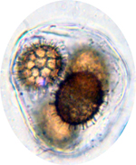
1.
2.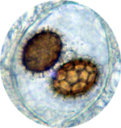

1-2 Imaging of fresh material in a drop of water x1000

Material Studied : Tuber Gibbosum
Collection Date : 14 June 08
Location : USA Polk County, Oregon
Habitat : Douglas Fir 30-40 year dense growth
Elevation 600 Ft. ASL
Truffler : Loren McMahill
Sample : ORND 081208 01

Bright Field Microscope Images :
Instrument : Trinocular Biological Microscope
Model : M837T
Digital Camera : Sony DSC-W80
Location : Home

Early this summer I had a chance to send a friend some
samples of Tuber gibbosum the Oregon spring white
truffle. He had the opportunity to get some time on an
Electron microscope, as well as his home microscope.

3. 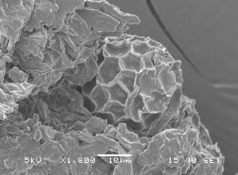

4. 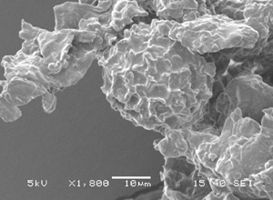 5. 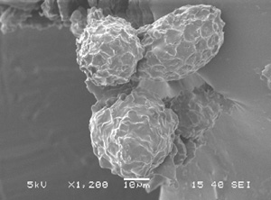

6. 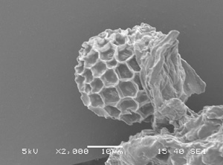 7. 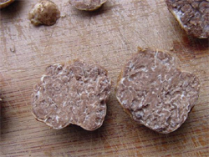

Scanning Electron Microscope Images : Tuber gibbosum
Instrument : SEM
Model : JSM-6480
Lab Technician : Ladd Rutherford
Location : Olympia, Washington
3 & 6: Imaging of dried material coated with gold and palladium.
7. Fresh example of the specimen
Thanks for the wonderful images Neil!
-----------------------------------------------------------------------------------------------------------------
NATS Editorial:
Finally, another addition! I’d like to apologize for my delinquency in producing this issue. I had quite a busy summer and fall this year, some things didn’t work out quite like expected, and quite a few unexpected things came up! My co-editor Lauren Holst is busy with her profession as a teacher and family and will be resigning form editorial duties, so we’d like to thank her greatly for all the help she’s provided with the NATS Truffler since we began last year as co-editors. Thanks Lauren!

NATS is losing/redistributing many senior officers and volunteers, and we’ll need to fill those positions. We need members to step up and become more involved. If you like the benefits of the forays and meetings and want to contribute, please let us know. If we don’t get some additional interest, at best we’ll cut back on NATS activities, at worst there won’t be enough people to
coordinate and staff NATS events. Contact lorenmcmahill@yahoo.com for more information.
Rainforest Fungus Naturally Synthesizes Diesel

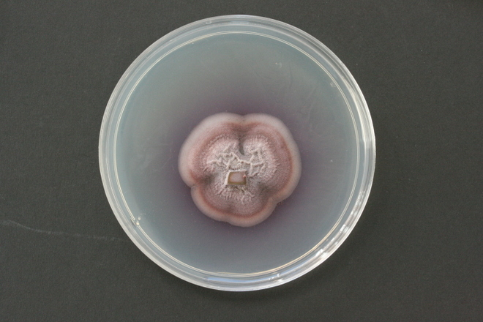

Gliocladium roseum.

A fungus that lives inside trees in the Patagonian rain forest naturally makes a mix of hydrocarbons that bears a striking resemblance to diesel, biologists announced today. And the fungus can grow on cellulose, a major component of tree trunks, blades of grass and stalks that is the most abundant carbon-based plant material on Earth.
"When we looked at the gas analysis, I was flabbergasted," said Gary Strobel, a plant scientist at Montana State University, and the lead author of a paper in Microbiology describing the find. "We were looking at the essence of diesel fuel."
While genetic engineers have been trying a variety of techniques and genes to get microbes to create fuel out of sugars and starches, almost all commercial biofuel production uses the century-old dry mill grain process. Ethanol plants ferment corn ears into alcohol, which is simple, but wastes the vast majority of the biomatter of the corn plant.
Using the cellulose from plants — the stalk instead of the ear, or simply wood from poplars — to make liquid fuel is a long-held dream because it would be more environmentally efficient and cheaper, but is far more difficult.
First, the cellulose must be broken down into its constituent parts — sugars bearing carbon — and then those pieces must be synthesized into more complex hydrocarbons. Both steps have proven difficult to do without applying large amounts of heat, pressure or chemicals.
"Traditionally that's been an energy-intensive process that also involves lots of chemicals," said Andrew Groover, a plant geneticist studying cell wall formation at the U.S. Forest Service's Pacific Southwest Research Station. "So, one approach is to look for situations in nature where there are organisms that can break down wood as part of their natural lifestyle: wood rot, fungi, termites."
What's exciting about the Gliocladium roseum fungus, however, is that it can both break down cellulose and synthesize the liquid fuel.
"A step in the production process could be skipped," Strobel said in a press release.
That said, the paper's authors admit that the technique is far from any sort of industrial production.
"This report presents no information on the cost-effectiveness or other details to make G. roseum an alternative fuel source," they write. "Its ultimate value may reside in the genes/enzymes that control hydrocarbon production, and our paper is a necessary first step that may lead to development programmes to make this a commercial venture."
The genome of the fungus is being analyzed at Yale University under the direction of Scott Strobel, a molecular biologist and Gary Strobel's son.
But beyond the biofuel implications, Strobel said that because the fungus can manufacture what we would normally think of as components of crude oil, it casts some doubt on the idea that crude oil is a fossil fuel.
"It may be the case that organisms like this produced some — maybe not all — but some of the world's crude," Strobel said.

http://blog.wired.com/wiredscience/2008/11/rainforest-fung.html

NEW MEMBERS

Jerry Eline Vancouver, WA
Kerry Hanson Corvallis, OR
Paula and Rollin Reynolds Washougal, WA
Barry Wulff Philomath, OR
James Schwarz & Springy Yamasaki Camas, WA
Robert Cantor Sutherlin, OR
Brent Clark Springfield, OR
Kurt Katsura Eugene, OR
Anna Moore Florence, OR
Zachary Williams AnneMarie Hoffman Portland, OR
Jerry Wilson Eugene, OR

We’d like to welcome all our new members and hope you enjoy the forays, meetings, and other benefits of being a NATS member.

MINUTES OF THE NORTH AMERICAN TRUFFLING SOCIETY

On October 7, 2008 NATS met in the Multi Cultural Center in Corvallis, Oregon.
The meeting was called to order by Vice President Marilyn Hinds.

Dave Pilz spoke first about his working on the constitution and by-laws including the duties of the officers. He has a mark-up copy and will do a clean copy within the next couple of weeks. Bold red print will be areas to be crossed out and blue will be the changes. This will give the board time to go over the changes Dave thinks need changes before the board meets in November.

By consensus, the board will meet on November 4th at 5:30 at the Multi Cultural Center and those so inclined can brown bag it. Dave will make sure we can have the meeting at that time.

A motion was made by Zelda Carter that NATS pay members the commercial Federal rate for mileage when working the mushroom shows. Dave Pilz seconded the motion and upon voting, all present approved the motion.

Marilyn asked who would be working the Yachats and Mt. Pisgah shows. Misty Webber and Betty Orner will work the Yachats show. Misty and Marilyn have volunteered for the Mt. Pisgah show.

Marilyn announced that she would store the materials for the show as well as the tee shirts and sweat shirts at her home. Pat Rawlinson was concerned about leaving them in her garage where they might draw dampness or mice.

The treasurer reported that as of October 7th the balance in the regular checking account is $5,131.00.

Marilyn wanted to know how many field guides we had at this time. Pat reported that we have a box of the old ones as well as the new ones. After a discussion it was decided that both guides should be displayed at the shows. The older version will be discounted and sold for $15 and the new version will sell for $16.95.

Marilyn reported on the October 3rd foray. About 8 or 9 people attended including two from St. Lewis. The area for the foray was on the West side of Alsea Falls and foraging there gave everyone a good cardiovascular workout! Six or more species were found including two small immature whites and 8 or more elaphomyces.

Marilyn also reported that Matt Trappe has been in communication with someone from CBS. This person might be at the Mt. Pisgah show and wants to go on a truffle foray as well as find out more about NATS.

At this time Marilyn Hinds introduced our speaker for the evening, Dr. Steve Carpenter, teacher and researcher. His presentation was titled, “Snow banks, frogs and mold: notes from a mercenary mycologist”. The Presentation was excellent and full of information including molds in the home, how to test for them and how to treat them.

Zelda C Carter,
Secratary.

MINUTES OF THE NORTH AMERICAN TRUFFLING SOCIETY

NOVEMBER 4, 2008

The meeting was called to order by Dave Pilz. Matt Trappe gave the truffle report for November 1, 2008. The area was on Lewisburg Saddle. Most people found something and a total of five species were identified. The next foray will be to the Paul Bishop tree farm on November 29th. Paul Bishop was named tree farmer of the year for Oregon.

Sylvia announced that the potluck will be December 6th at the Corvallis Sr. Center at 6:00 p.m. She needs volunteers for center pieces as well as help setting up, beginning at 5:00 p.m.

A condensed report on the board meeting was given at this time. Attached to these minutes will be the minutes of the board meeting. The two motions which were passed were read to the members. Dave told the members that one of our concerns is the continuation of NATS. He put out a plea for volunteers for the offices of President, Vice President, Secretary and Exhibit Chairman. He said he would also ask Jim Trappe to talk about NATS before he gives his presentation at the potluck.

Zelda Carter reported that we have around $5,500 in the checking account.

At this time Jonathan Frank spoke on underwater mushrooms. These mushrooms were discovered in the Rogue River area in 2005, again seen in 2007 and 2008.

Refreshments were supplied by Helen Yahiku.

2008 Membership Dues
NATS Annual membership is from January 1 to December 31 each year. Dues are tax deductible to the full extent allowed by law. Renew your dues with this form and keep your cancelled check as your receipt. Fill in and mail your check made out to:
NATS
P.O. Box 296
Corvallis, Oregon 97339-0296
Name(s): Phone: ( )
Address: Zip
Email:
First family member ------------------------------$10.00 Foreign Membership -------------$15.00
Each additional family member ---------------$5.00 Contributor---------------------------$50.00 - $499.00
(must live in same household)
Sustaining member-------------------------------$500.00

North American Truffling Society  P.O. Box 296  Corvallis Oregon 97339 |  | Non Peofit Org  U.S. Postage  Paid  Corvallis, OR.  Permit No. 104

