The North American Truffler
Journal of the North American Truffling Society

Volume 27, Issue 1 April/May 2008

Candid Camera

Modern technology is providing researchers
Inside This Issue
6 | Fungal Extracts to Purify Water
7 | Morels in Istanbul
8-9 | Truffle Custard Recipe and Casserole Recipe
10 | Minutes of the North American Truffling Society- March
11 | Minutes of the North American Truffling Society- May

with an alternative to trapping to help study

native animals, Rosslyn Beeby reports.
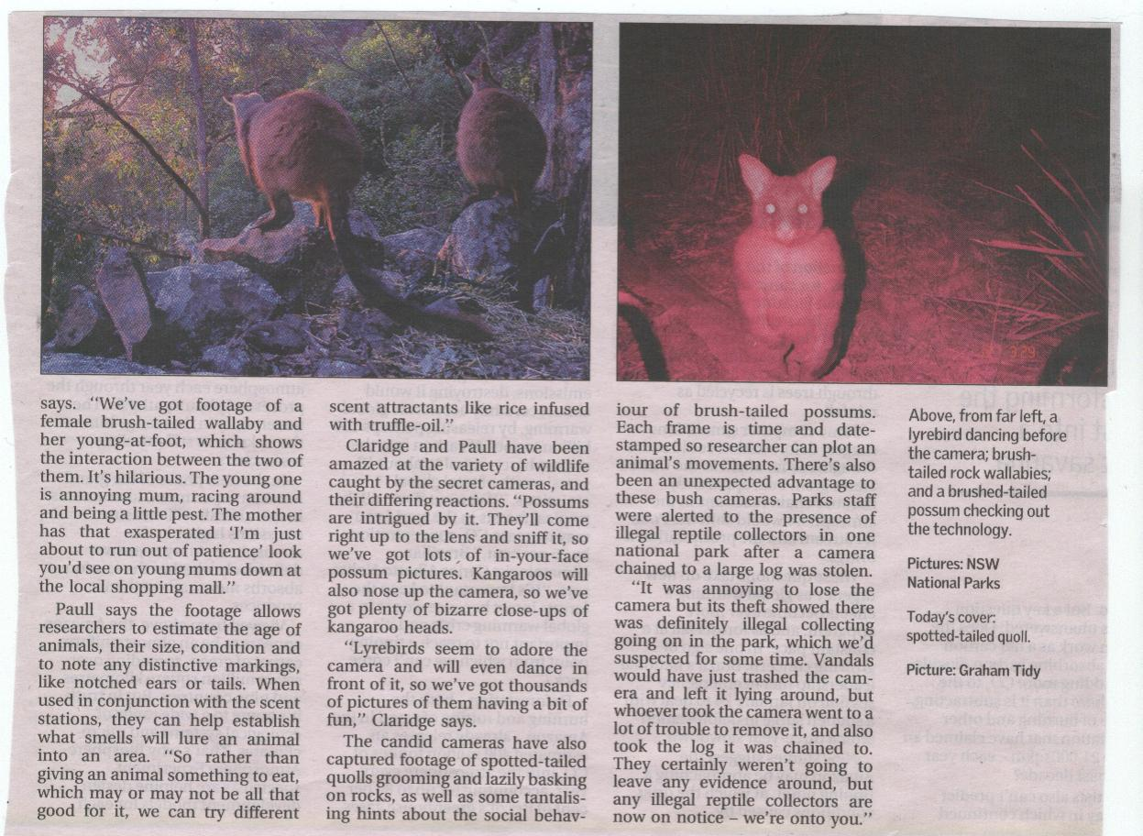

A brush-tailed possum checking out the technology.

Imagine running a well-stocked gourmet deli and overhearing a bunch of blokes deep in scientific discussion over the olfactory merits of various brands of imported, black truffle-scented salad and cooking oils.

Perfection-seeking local celebrity chefs in the making? Well-paid public servants who love splashing out on elegant fine dining? Don’t bet on it. That much-discussed bottle of exquisite truffle-infused French salad oil could be destined for a wildlife bait station in a national park- perhaps the NSW south coast or the remoter regions of East Gippsland – where it will be tentatively (but appreciatively) sniffed by a curious bandicoot or potoroo.

“The question we started to ask ourselves was, why are we still using peanut butter and rolled oats to bait traps? Do animals actually like the stuff?”

Continued on page 2

“It’s the method that’s been used for the past 40 years, but isn’t there something better, or something more closely related to the animal’s natural diet we could use,” NSW Parks and Wildlife ecologist Andrew Claridge says.

He was also pondering “ethical questions” about the need to trap native animals for research surveys, “just to find out where they are,” and was convinced modern camera technology could provide a solution.

“If we can put security cameras out in the streets to watch people or catch speeding motorists, then why not put cameras out in the bush? Let’s at least give it a go and see what kind of results we get.”

Claridge was working with geographer Dr. David Paull from the University of NSW on a series of bandicoot surveys, when the two scientists began wondering if “lugging cage traps around in the bush” was the best use of resources in tracking these notorious elusive animals. Could they develop a better way to map an animal’s distribution? “There are safety and ethical issues with rap, both for the animals and the researchers,” says Paull, who has studied bandicoot populations in South Australia and southern NSW for well over a decade.

“You need to calculate how long animals will remain in he traps when you’re mapping out a potential trapping grid. If you set them in the evening, how quickly can you empty the traps when you’re checking them in the morning?

And if there’s an unexpected delay, you’re panicking about getting around the rest of the traps in time. You need to provide an estimate of these things to ethics committees when they’re approving a research project, and they’ll usually ask if you can possibly cut down your trap time – ‘Can’t you get around the traps any quicker?’ So that time factor is quite an important issue and does affect the way you do our research.”

Claridge has conducted long-term research on spotted-tailed quolls in Kosciuszko National Park, as well as bandicoots and potoroos in southern SW and East Gippsland. He’s used to setting traps in rugged, remote alpine country, and is well-aware of the occupational safety issues facing equipment-laden researchers as they clamber over slippery rocks, negotiate swampy patches of bushland or disturb eastern brown snakes while doing the rounds of a trapping grid. It’s not exactly a walk in the park, and after several exhausting days, a researcher can drive away with little to show for their efforts but empty traps and a few animal hairs collected on strategically-placed patches of sticky tape in Perspex tube-tunnels.

“But the biggest disadvantage of traps you’re

changing an animal’s day. You’re interrupting its routine and maybe even making it vulnerable to predators. You’ve got to ask

yourself, is that a good thing? Is it even necessary and is there a better way of doing things that will avoid placing any stress on the animal?”

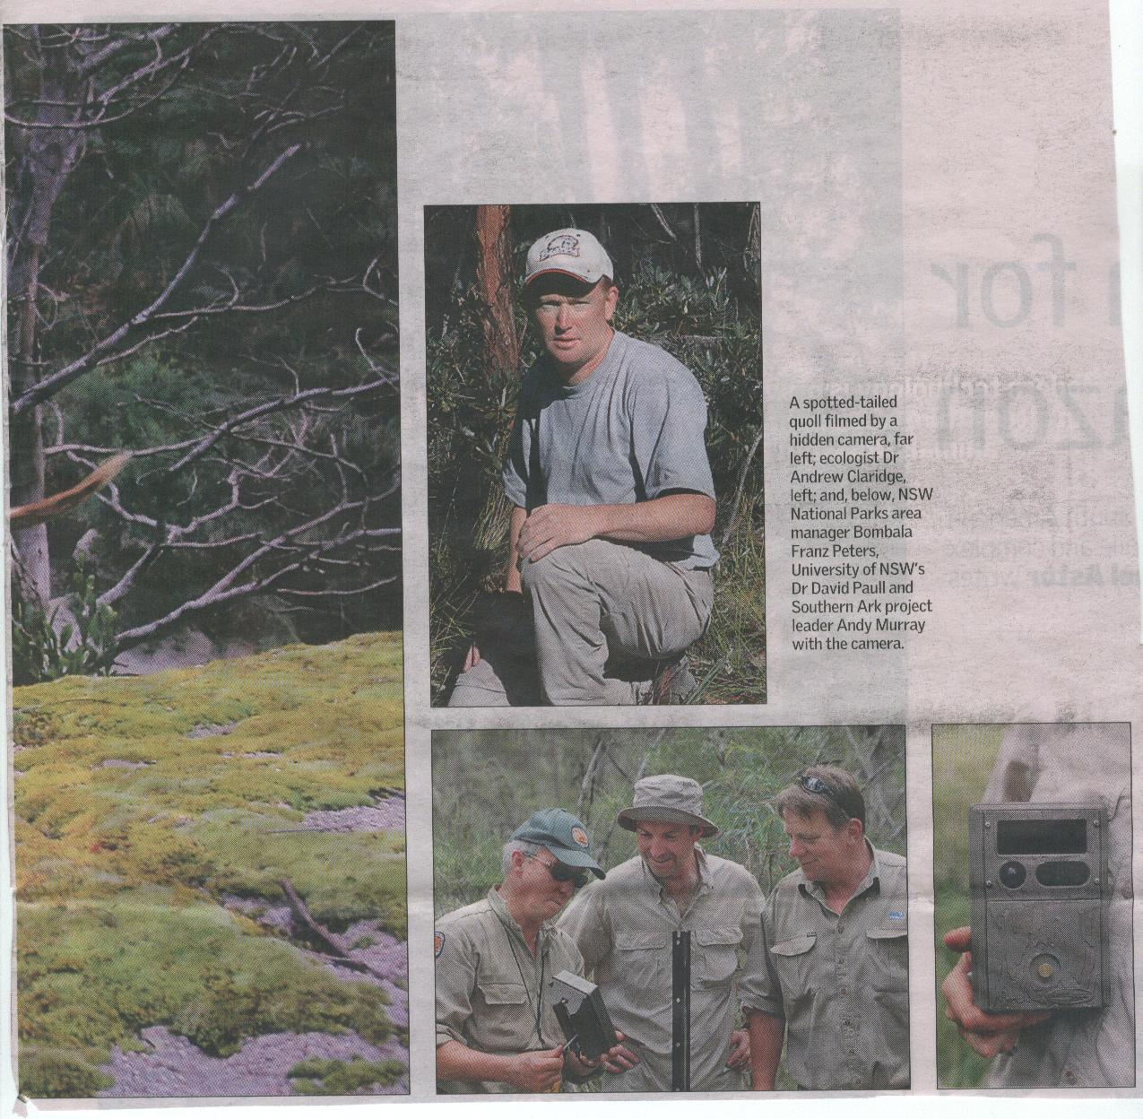

Ecologist Dr. Andrew Claridge

NSW National Parks area manager Bombala Franz Peters, University of NSW’s Dr. David Paull and Southern Ark Project Leader Andy Murray with the camera.

Claridge and CSIRO researcher Dr. Fred Ford had experimented with infra-red cameras during a trapping survey for southern brown bandicoots and long-nosed potoroos in Ben Boyd National Park in southern NSW. The results were encouraging, and enlightening potoroos had apparently been digging for fungi, the traps had remained empty for several nights in a row. Fresh diggings showed the animals were clearly around, but what was the problem?

The cameras showed the potoroos were certainly there, but weren’t attracted by baited traps. But a later experiment with a scented bait station (a bait enclosed in a mesh structure, which the animal can sniff but not eat) showed they were attracted by smells that more closely resembled the underground fungi – bush truffles - that they eat.

Brush-tailed rock wallabies

“And when you tink about it, why not? It makes a lot more sense than using peanut butter and rolled oats as a scent lure,” Claridge says.

During a recent trip to the United States, Claridge came across a small, inexpensive battery-operated camera called a Cuddie Back, which was developed by deer hunters to locate animals.

“Doing the sums, these things made more economic sense than traps, and they meant you could sample an environment for 24 hours a day.”

The NSW Parks and Wildlife Service and the Victorian Government’s Southern Ark project have installed 50 of the Cuddie Back cameras across a range of habitats in southern NSW and eastern Victoria, as part of an experiment in tracking wildlife movements. The results have been “amazing, funny and given us lots of new information on animal behavior to think about,” Claridge says.

“We’ve got footage of a female brush-tailed
wallaby and her young-at-foot, which shows the interaction between the two of them. It’s hilarious. The young one is annoying mum, racing around and being a little pest. The mother has that exasperated ‘I’m just about to run out of patience’ look you’d see on young mums down at the local shopping mall.

Paull says the footage allows researchers to estimate the age of animals, their size, condition and to note any distinctive markings like notched ears or tails. When used in conjunction with the scent stations, they can help establish what smells will lure an animal into an area. “So rather than giving an animal something to eat, which may or may not be all that good for it, we can try different scent attractants like rice infused with truffle oil.”

Claridge and Paull have been amazed at the variety of wildlife caught by the secret cameras, and their differing reactions. “Possums and intrigued by it. They’ll come right up to the lens and sniff it, so we’ve got lots of in-your-face possum pictures. Kangaroos will also nose up the camera, so we’ve got plenty of bizarre close-ups of kangaroo heads.

“Lyrebirds seem to adore the camera and will even dance in front of it, so we’ve got thousands of pictures of them having a bit of fun,” Claridge says.

The candid cameras have also captured footage of spotted-tailed quolls grooming and lazily
basking on rocks, as well as some tantalizing hints about the social behavior of brush-tailed possums. Each frame is time and date-stamped so researchers can plot an animal’s movements. There’s also been an unexpected advantage to these bush cameras. Park’s staff were alerted to the presence of illegal reptile collectors in one national park after a camera chained to a large log was stolen.
“It was annoying to lose the camera but its theft showed there was definitely illegal collecting going on in the park, which we’d suspected for some time. Vandals would have just trashed the camera and left it lying around, but whoever took the camera went to a lot of trouble to remove it, and also took the log it was chained to. They certainly weren’t going to leave any evidence around, but any illegal reptile collectors are now on notice- we’re onto you.”

Andrew did his Ph.D. Thesis on ecology of the long-nosed potoroo, a miniature member of the kangaroo
family, that subsists to a large degree on truffles.

Andrew discovered that the seasonal movements of this little marsupial related to where truffles were fruiting. Accordingly he wound up doing much of his thesis research on when and where truffles
were to be found in southeastern Australia. In the course of that he discovered many species new to science and contacted Jim Trappe to propose collaboration. With his Ph.D. in hand,
Andrew applied for and was awarded a Fulbright Fellowship for a year of research (1994-1995) with Jim in Oregon and Washington, where he studied the nutritional values of various truffles to northern flying
squirrels, chipmunks, deer mice and red-backed voles, among other things. Since then he and Jim have collaborated annually in research on Australian truffles. Andrew now is a Senior Research Scientist with the New South Wales Department of Environment and Climate Change, Parks and Wildlife Division, with specialties in animal ecology. His interest in truffles continues: he is a member of NATS, and many members remember him well. He and his family will visit Oregon this year in July.

Fungal Extracts to Purify Water

Russian scientists develop effective sorbing agents on the basis of fungal chitin.

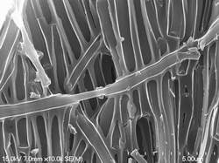

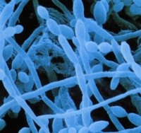
Fungal hyphae
Ability of various fungi to absorb heavy metals is a widely known fact – that is why even edible mushrooms, which grow in non-healthy ecological areas, can damage human health. This property has a simple explanation – all mushrooms contain chemical compounds, which include chitin, a polysaccharide with effective sorbing properties. Scientists suggested using said compounds for “catching” heavy metals, thus purifying water and water solutions. Mushroom bodies can also be used as sorbents; however, extracted compounds are much more effective.
Russian biologists have done an enormous piece of work - they found fungi with needed components, extracted said components, identified them and found out, which fungi contain more substances of interest. Biologists started with collecting various types of
mushrooms – higher fungi Basidiomycetes (fungi with many-celled mycelium, like honey agarics, paxils, champignons and fly agarics) and Ascomycetes (cup fungi, like morels), drying and
mincing them. Then fungal powder underwent successive extraction with sodium hydroxide,
hydrochloric acid and hydrogen peroxide solutions. Scientists extracted chitin complexes with other polymers: chitin-glucan complexes and chitin-glucan-melanin complexes. After that mentioned compounds were identified, and their sorbing properties were studied on cadmium and nickel ions.
However, some fungi showed weak sorbing properties, despite they were rich in chitin. Worst sorbents for cadmium were extracted from Ramaria flava (an edible mushroom, which looks like coral), and bad absorption solution for nickel came from sharp agarics (Lactarius torminosus). Mentioned fungi aren’t suitable for purification water from heavy metals. Anyway, extracting process takes a long time, since chitin-containing compounds should spend in solution about an hour for most full extraction.
Scientists currently search for a sorbing agent for another serious toxin – water-soluble lead compounds, and at the same time study effects of dye sorption on said compounds. Of course, they do not forget about making affordable product out of fundamental research.
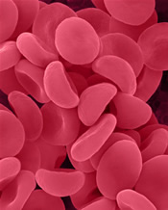
Scientists from other Russian regions also rack their brains over new sorbents – in the end of 2008 researchers will present an experimental industrial unit, which contains carbon sorbents and makes purification of industrial gases and liquids possible. These units will prevent emissions of finest particles from enterprises of ferrous and non-ferrous metallurgy to the atmosphere.
Brand new carbon sorbent is developed in Saint-Petersburg, moreover, a new pack for this sorbent is created – this pack provides perfect sterile conditions. New sorbent is covered with fluorine, shows high sorption capacity and doesn't damage blood corpuscles. This very useful substance in packed into a sterile column, preventing dust generation while storing and transporting.
Source:
Science & Technologies
Kizilova Anna
February 19, 2008

Morels in Istanbul

I'd been looking hard to find a single morel since I became interested in foraging mushrooms until three weeks ago when I found my first morels. Before that, I'd visited many web pages on the subject and had read carefully all the tips by experts such as about, when and where to find them.

On the third of April, I took a walk in the woods around the campus of the university where I work. The first part of the woods I searched was the burnt side. I looked almost everywhere but did not find a single mushroom. Just as was about to lose hope, I came across a Chinese woman, who knew neither Turkish nor English except for a few words. With the help of gestures and mimics, we tried to communicate. By drawing pictures, I tried to tell her that I'm looking for wild mushrooms. I also showed her a photograph of a few morels that the villagers showed me a few days earlier. Suddenly her eyes lit up and, waving her hand, she asked me to follow her. I did.

She led me to a place which I’d passed by a quarter of an hour before and pointed to a corner of the path. Oh my! What beautiful morels they were! I took lots of photos of them. Two days later, I went to the woods again to find some more morels just on the side of another path among some pebbles. You can’t imagine my excitement at that moment. Now I know where to look for morels next spring. On the same day, I also found a weird mushroom, which was a false morel. And some greenish yellow ones with an acrid smell.

It's nice to share this feeling with others. When I tell about it to my friends here, they think that I'm exaggerating the matter. I checked the same place the other day just to find four more morels, two of which had started to decompose, and one had gone dry and lost its beautiful colour turning to gray.
I teach English at Yeditepe (Seven Hills) University in Istanbul, Turkey. About the edibility of wild mushrooms, I depend mostly on the local people who are certain about the kinds of mushrooms. Most of my friends tease me saying that I'll end up in the grave because of the love of mushrooms. Morels are a rare kind of valuable mushrooms here and the local people call them "Kuzu Gobegi,” which means "The Lamb's Belly." But I can't see the connection between the shape of the morel and that part of a lamb. There are no mycological societies here. Some people are individually interested in the matter and trying to establish a contact between the people who have the same interest.

When I found my first morels, the temperature was around 30 degrees Celsius. Then it fell to 12 - 15 C during the day and colder at night, so when I went to check the same area in hope that I could find some more the other day, I found a frozen morel. I'll keep on looking for them. The place where I found the morels is about 150 metres above the sea level and it's a small woods area where there are pine trees, oaks, ferns, bushes, shrubs, and wild flowers such as butter cups, blue bells and many others whose names I don't know.

Adnan Sinar

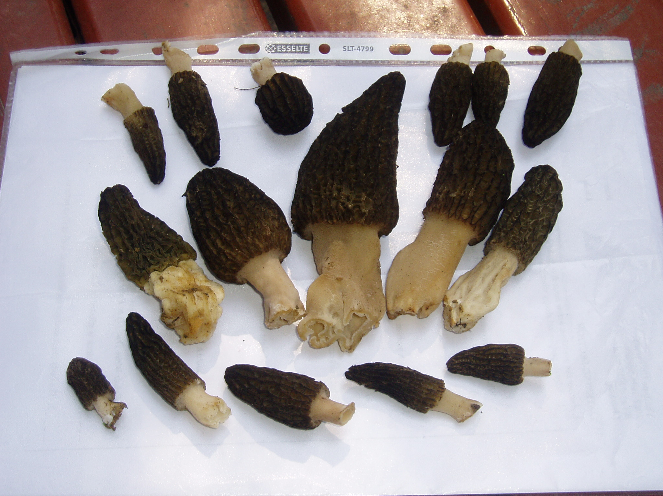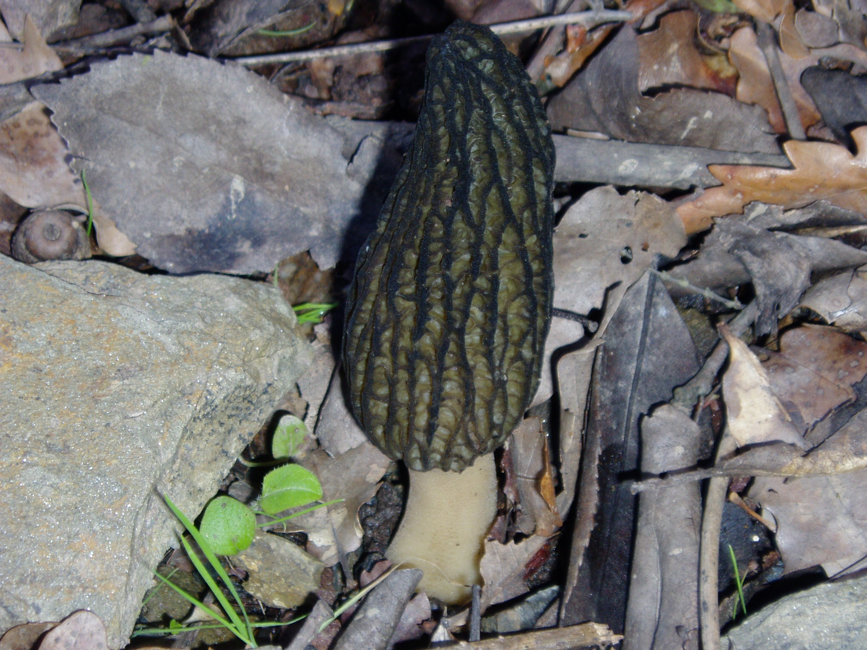

Truffle Custards with Crab and Caviar

Recipe adapted from Brad Farmerie, executive chef at Monday Room wine bar in New York. Photo from The Associated Press, January 23, 2008.
A wonderful delicate truffle custard to use as a first course or appetizer for your dinner party.

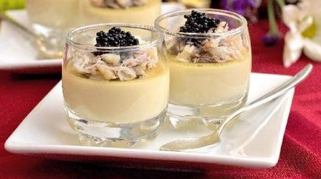
2 eggs
1 egg yolk
1/2 teaspoon white Truffle Oil
2/3 cup heavy cream
1/3 cup milk
1 tablespoon soy sauce
1/2 pound jumbo lump crabmeat
1 tablespoon finely chopped chives
2 teaspoons lime juice
Salt and freshly ground black pepper, to taste
1/2 ounce hackleback (or other black) caviar

Preheat the oven to 325 degrees F. Adjust oven rack to center position. Arrange 12 shot glasses in a 9-by-9-inch baking pan.
Bring a kettle of water to a low simmer over low heat.
Meanwhile, in a medium bowl whisk together the eggs, egg yolk, and truffle oil; set aside.
In a small saucepan over medium heat, combine the cream, milk, and soy sauce. Bring just to a boil, stirring constantly; remove from the heat and let cool 1 minute. Whisking constantly, slowly pour the hot cream mixture into the eggs. Immediately strain the mixture through a mesh strainer into a large liquid measuring cup (or other container or pitcher with a pouring spout).
Carefully pour the strained mixture into the shot glasses, filling them about 3/4 full. Carefully pour enough hot water from the kettle into the baking pan to reach halfway up the shot glasses.
Cover the pan with foil and bake approximately 9 to 10 minutes or until a knife inserted near the center comes out clean (the custards should be firm at the edges and just barely wobbly at the center). If needed, cook another 1 to 2 minutes. Remove the pan from the oven. Remove from oven and immediately remove cups from water bath. Let cool at room temperature until ready to serve.
While the custards cook and cool, prepare the crab. In a small bowl, gently mix the crab, chives, and lime juice. Season with salt and pepper.
To serve, spoon a small amount of the prepared crab mixture over each custard, then top with a dollop of caviar.
Makes 12 shot glasses.

Truffle-Topped Mushroom Potato Casserole
Norene Wedam

To 1 1/2 c. white sauce, add 1/8 t. powdered saffron and a dash of white wine and tamari to taste.

Add 2 medium-sized fresh shitake mushrooms, sliced in half and each half sliced thinly in the
shortest direction.

Cook mushrooms in sauce until sauce is thick.

One dozen small new potaoes, about the 2" each, halved and boiled. Drain and add to sauce .

Place all in greased casserole (cover with foil) and heat through at 350 degrees until bubbly.

Remove from oven and sprinkle with grated truffle. I found Rhizopogan vinicolor worked very
well for this, but any truffle will work.

Let ripen 5 minutes and serve in bowls since there is a lot of sauce.

Truffle Casserole

MINUTES OF THE NORTH AMERICAN TRUFFLING SOCIETY

March 4, 2008

Marilyn Hinds brought the meeting to order. She informed the group that the board had met prior to the meeting and had approved several things that would need to be voted on by the members.

Jim Trappe moved that Zelda Carter be appointed treasurer. Pat seconded the motion and members voted their approval.

Matt Trappe moved that Loren McMahill be appointed the Librarian. Pat Rawlinson seconded the motion and the members voted their approval.

Zelda moved that Pat Rawlinson be appointed a Member at Large. Nancy Weber seconded the motion and the members voted their approval.

Dr. Matt Trappe gave the truffle report for March 1st to the Starker Forest area. Twenty-two people showed up and a variety of truffles were found by everyone. The next foray will be to the Hebo area at a forest service camp there. There is a Sitka Spruce stand there and it is an area where Thaxterogaster have been found in the past. The May foray will be the annual Metolius foray and the date will be set at a later time to coincide with the weather and other mushroom groups. He also announced that the amount of people attending the forays showed an increase after November of 2004. Marilyn and Sylvia noted that people in the Eugene area as well as the Portland area would like some forays in their areas. It was suggested that a note be placed in the next newsletter for people who want to volunteer their land to contact Matt. Also, there should be a note on what the criteria of the area should include such as parking space, type of habitat, and terrain not too steep for ease of walking.

Someone asked if we had heard how Welles was doing. Jim Trappe said he talked with him about a week ago and he still tires easily but was getting cabin fever.

Sylvia brought up the problem of trufflers digging up an area and not returning the duff before moving on. The problem will be proposed to Jim Welles who is a commercial picker and a future speaker. It was proposed that a pamphlet on good practices of foraging be printed and handed out to people at the forays. The pamphlet could also be handed out at the mushroom shows. Mysti agreed to head a committee to put together something. Sylvia, Loren and Matt will also help on that committee. Dave mentioned he had made-up one for the Yachats show and he would contribute that information.

Marilyn introduced our speaker for the evening, Dr. Jim Trappe, who spoke on “Truffles: Have they a role in Modern Science?”

At the conclusion of the meeting we enjoyed refreshments brought by Pat Rawlinson.

Respectfully submitted,

Zelda Carter, Sec.

MINUTES OF THE NORTH AMERICAN TRUFFLING SOCIETY

On May 6, 2008, the meeting was brought to order by vice president, Marilyn Hinds.

Marilyn asked Matt to report on the upcoming forays. He brought permits for the Metolius foray for people who don’t have access to the web site to download one from there. The permit is only good for the 17th and 18th of May, 2008. He announced that the June foray, which will be on May 31st, will be in the Vancouver, Washington area. Frank Evans will be leading the foray and when Matt has more information it will be posted on the web site.

A balance of $6,165.00 was reported to be in the NATS checking account.

Pat Rawlinson announced that Loren McMahill now has possession of the library. Marilyn asked if this was available only to NATS members. The response was yes, plus other Mushroom Clubs.

Sylvia wondered if there had been any response to the information going into the truffle pamphlet. Matt said he had an email from Mysti and had responded to her that he would like additional information before putting it on the site for comments. Loren said it was not ready yet but they are working on it.

Charlie suggested that the draft be proof read by people who had already worked on the problem of proper harvesting of truffles.

Marilyn turned the meeting over to our speaker for the evening, Jim Wells, who is a commercial buyer. Jim gave a lengthy reading of his history both collecting and purchasing truffles. He also had a graph showing the price truffles were purchased for and sold by him and other buyers. When questioned about whether he thought there has been progress with the collecting, purchasing and then use of truffles he answered that he thought yes, but that there was still a long way to go in education of the pickers, buyers and users.

The meeting was adjourned to enjoy the refreshments provided by Sylvia Donovan.

Zelda Carter,
Sec.

Editors’ Note:

Hello Everyone,

We hope everyone is enjoying fruitful truffling expeditions!

If you have any suggestions or would like to submit any articles please contact Loren McMahill at lorenmcmahill@yahoo.com or Lauren Holst at holst007@aol.com.

Sincerely,

Loren McMahill and Lauren Holst

The North American
Truffler

North American Truffling Society  P.O. Box 296  Corvallis Oregon 97339 |  | Non Profit Org  U.S. Postage  Paid  Corvallis, OR.  Permit No. 104

