Inside This Issue
1 | 2008 Oregon Truffle Festival / Truffling with Jack
3 | Calendar of Events
5 | The Truffle Kerfuffle: Mystery Mushroom Vanishes
8 | Chanterelles and Apples. A Risky Combination?
12 | New Membership/ Renewal Application for 2008

The North American Truffler
Journal of the North American Truffling Society

Volume 25, Issue 4 December/January 2007-2008

The 2008 Oregon Truffle Festival

What: The Oregon Truffle Festival celebrates the native truffles of the region as well as the growing truffle cultivation industry in North America. It serves purely epicurean interests, as well as the interests of those for whom truffle harvesting or cultivation are paths to the good life. Truffles are magnanimous collaborators, and as such, the Oregon Truffle Festival shares the stage with the glorious foods and wines of the region - the remarkable cast that supports this starring role.

When and Where: The Oregon Truffle Festival 2008 offers a variety of ways to participate. Mark January 25-27, 2008 on your calendar for this unique experience. All events are located in and around Eugene, Oregon.
General Recommendations
Workshops and events filled quickly in 2007. Early registration is recommended.
January in Oregon is cold and often wet; dress for the weather particularly if you are attending the truffle foray or truffiere tour.
Truffles in Oregon
In the rarified world of truffles, Oregon is known as the premier center of research and expertise outside of Europe. A lineage of eminent scientists has maintained that standing for almost a century, and continues to hold it to this day.
Oregon is also blessed with an abundance of wild truffles with superb culinary qualities, and as with French grapes, Oregon has the perfect climate for cultivation of the renowned French truffles.
As the ultimate culinary delicacies, truffles are emblematic of the epicurean life in every region where they grow. In Oregon they are complemented by our wealth of wild and cultivated gourmet foods and an increasing number of extraordinarily talented and award winning chefs. On this continent, Oregon is the natural place to celebrate these diamonds of cuisine.

Truffle Hunting With Jack Czarnecki
By: Loren McMahill

I had been anticipating an interview with Jack Czarnecki for a few months and the time finally arrived. Jack has appeared on about 35 television stations across the country including "Good Morning America" (two times), "The Home Show," "Regis and Kathy Lee," "the 60-Minute Gourmet," "CBS Morning News" and several cable features including three appearances Food Network, The Discovery Channel, and QVC. In Pennsylvania, Jack hosted his own television show, "At the Table with Jack Czarnecki," on Eastern Pennsylvania cable.

continued on page 2
continued on page 3

2008 FESTIVAL HIGHLIGHTS
Join us in a celebration of truffles, from their hidden source in the forest to their glory on the table. For three extraordinary days in January, we invite you to an experience unique in North America. Only at the Oregon Truffle Festival can you:
- Experience multiple course truffle dinners prepared by some of this region's most renowned chefs.
- Drink Oregon’s finest wines paired with our magnificent native truffles.
- Chase truffle dogs on the hunt.
- Savor a Truffle Marketplace with its wealth of local artisan foods, truffle tasting and truffle cooking demonstrations.
- Meet people from all over the world who share a passion for all things truffle.
Grand Truffle Dinner
Considered by many to be the pièce de résistance of the weekend, the 2008 Grand Truffle Dinner features five of the Pacific Northwest's most celebrated chefs and will again be hosted by 2006 James Beard nominee Stephanie Kimmel and Executive Chef Rocky Maselli of Marché in Eugene. We are delighted to announce the five guest chefs for 2008:
- Caprial and John Pence of Caprial's Bistro in Portland, 1990 recipient of the James Beard Award for Best Chef of the Northwest.
- John Sundstrom of Lark in Seattle, 2007 recipient of the James Beard Award for Best Chef of the Northwest.
- Cathy Whims of Nostrana in Portland, named Best Restaurant in Portland in 2006
- Daniel Mattern, Executive Chef at Clarklewis in Portland

Book Launching
We are honored to announce the premier of the new book Taming the Truffle: The History, Lore, and Science of the Ultimate Mushroom (January 2008, Timber Press), "the most comprehensive practical treatment of this gastronomic treasure to date" at the 2008 Oregon Truffle Festival. The Festival keynote address, open to all package holders and participants in the Truffle Growers' Forum, will be presented by two of the book's authors, Dr. Ian Hall from New Zealand, the leading researcher behind the success of truffle cultivation outside of Europe, and Dr. Alessandra Zambonelli, one of Italy's foremost truffle researchers. Taming the Truffle: The History, Lore, and Science of the Ultimate Mushroom (January 2008, Timber Press) will be available to Festival attendees several weeks before it will be available in bookstores.

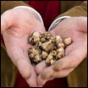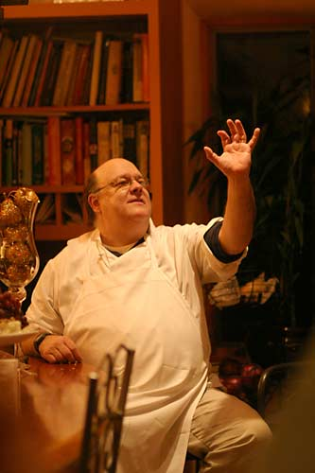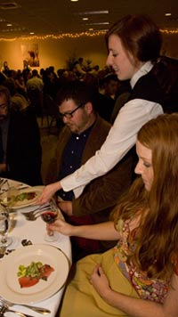
continued from page 1

Calendar of Events

Oregon truffle Festival
Place: Eugene Oregon
Time January 25-26-27
see front page
http://www.oregontrufflefestival.com/

January Foray
Place: Paul Bishop's tree farm and study area
Time Saturday, January 19th 10:00 A.M.
http://www.nattruffling.org

SOMA Winter Wild Mushroom Camp
Place Occidental, CA
Time January 19-21, 2008
http://www.somamushrooms.org/camp/camp.html

that time. Of course time flies and before you know it, winter is here. Once I had the opportunity to speak with Jack, I asked him about his preferred method of interview. He thought a truffle hunt would be the best as we would have plenty of time to talk about truffles. Of course, I was all for that.

So after the big storm on Monday the 10th that flooded everything and closed all the roads and the inability to get out of work on my part later in the week, we managed to go right before Christmas. Fortunately, the forecast said there was a break in the rain for the day. I got to The Palmer House at about 8:00 a.m. and met Jack and two of his partners, Ken Becket a former editor for the Oregon Mycological Society Publication and a gentleman by the name of Dick (who’s last name I didn’t catch but who was a great guy just the same). Dick had a custom truffle rake. I thought I was going to be pretty slick with my extendable handle rakes with the mattock on the flip side of the rake. Then Dick busted out with a rake that’s a 6 footer and has 6-7 big tines on it. Obviously, this man has contacts in the yard and garden implement industry, and is a man to be reckoned with. Jack pops the trunk on his 4 x 4 Subaru filled with various things like a wide variety of truffle forks, containers (including milk cartons with a belt that ran through the handle), boots and mud gear. These guys were prepared. I was in the presence of greatness! My extendable handle rake-mattocks stayed in my trunk, shiny and unused.

So we all piled in with rake handles passed up through the middle of the truffle-wagon and headed out from Dayton down the Willamette Valley toward the coast, in a round about way. As we drove through the Willamette Valley wine country passing a variety of vineyards along the way, it was great to listen to Jack talk about tales of mushroom hunting and truffle hunts of previous years, such as finding 150 pounds of King Boletes out on the coast, but ending up chest deep in mud and water (from which he had to be extracted by his friends) trying to make it over to them. We also chatted about the truffle market, and expressed our opinions on that and what things might help it progress. There was an article worth writing in that conversation alone, but I’ll save that for another time. It was pretty cold out and there was even some patchy ice on the back roads, not to mention a few large log trucks. But not to be deterred we rolled onward.

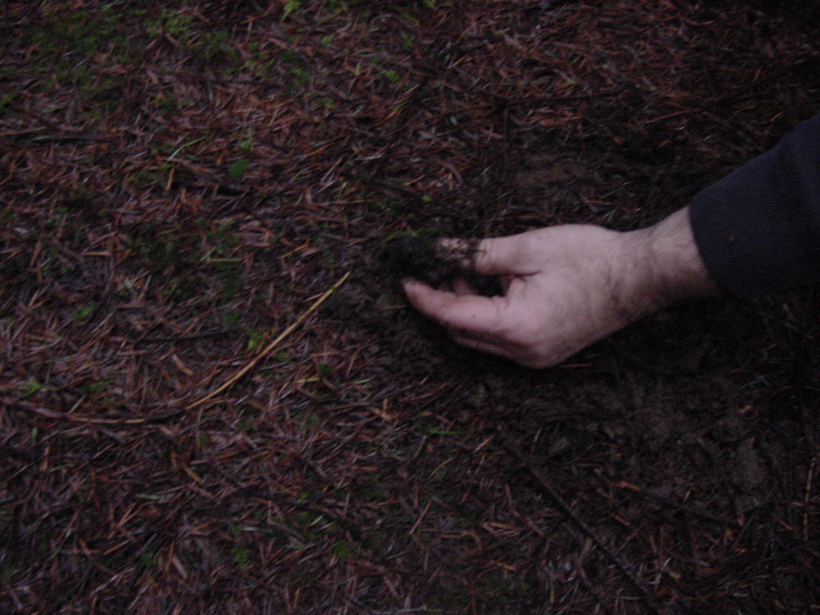 “The Getz method”
continued from page 1
Feature stories have appeared about Jack in virtually every metropolitan newspaper in the United States with numerous features in such papers as The Chicago Tribune, The New York Times, Philadelphia Inquirer, Star, USA Today, Nation's Restaurant News, The Christian Science Monitor, The Wine Spectator, The San Francisco Examiner and The Washington Post.
Jack has won numerous awards, written several books, and been a guest chef and judge in many wine and food competitions and events. I’d heard about him through word of mouth several years ago since I had family that had stopped by for dinner back in the 90’s. But that was before I’d really gotten into mushroom and truffle hunting. Since I became editor for The North American Truffler and I have repeatedly come across his name in my search for truffle knowledge, I was interested to learn more about Jack.
I contacted Jack back in August about an interview on truffle cuisine and what he might be doing for the next year’s truffle festival, that way I could time it to coincide with the next issue of the newsletter to come out at about

We finally pulled up to a small patch of woods, that looked pretty much like any other patch of woods you might find in Oregon’s coastal mountains. It was basically a 3-4 acre stand of Doug Fir with little undergrowth. The trees were mostly around 25-50 years old. We all got out and grabbed our chosen truffle implement and preferred truffle container from the back of the car. I thought a whole gallon milk container was pretty optimistic, so I opted to use my cargo pockets.

Everyone started off to go look for a likely place, scanning the ground and raking anything that appeared promising. I started to find and pocket Tuber oregonenses right away, along with plenty of Hymenogasters and the occasional Rhizopogon, which I left for the squirrels. It wasn’t long before someone said, “I found one!” then you’d hear the resounding “thunk” in the bottom of the milk carton, which was a fun reoccurrence throughout the morning. I, myself, wasn’t having as much luck. I was finding plenty of whites, but no blacks.

Finally I managed to find one. Of course I broke it in half with the rake and it was small and unripe, white on the inside with no real smell. But hey…it was a black and the only one I found for about the first three hours, which was rather discouraging, considering all the “thunks” and comments of “Found one!” or “Found two!” I kept hearing. Eventually I found a few up by the edge of the clearing near a younger tree. So I was finally happy to have found a few that were whole. That spot played out and we were looking around when Jack called me over.

He said, “Let me show you something. See all those little holes behind me? There was a truffle in each one I pulled them out with my finger. Look around for little bumps on the surface. It’s best to do it from about knee level.” Of course he’s in waders and I’m wearing cargo pants and although eager to learn, was hesitant at the prospect of wet and muddy knees for the rest of the day. “There’s one. Try that.” I poked my finger in and no luck. “Sometimes they’re in deep,” he said. So I poked again, but further. Still nothing.

“Well, try that one.” He pointed to another innocuous bump. I dropped my finger beside the bump and boink, a black truffle popped up out of the ground. So I started looking around for little bumps. Jack went on to say, that’s called “The Getz Method” of harvesting.

“The Getz Method? What’s that?” I asked, looking around for more bumps to poke at.

“John Getz harvests his this way. He doesn’t use a rake. This method makes the least impact on the environment. Just look around for them and pull them out with your fingers.” So I made a mental note to Google John Getz. Turns out The Getz Method was perfected on identification of matsutake bumps and applied to truffling. Not to mention John Getz was the guy to associate Allotropa Virgata with matsutakes. Seems like there’s a story worth pursuing for a future article.

I managed to pluck truffles from the Earth with my fingers at least three times successfully. One was the size of a black walnut. That was probably the highlight of the day. There’s nothing quite like spotting a bump and plucking a black truffle right straight from the ground. It was almost like magic. We were in a nice sized patch of blacks. And the four of us managed to get enough to make the buckets quit making the hollow thumping sound.

I didn’t realize Leucangium carthusianum grew in patches to this extent. I had only seen people find a few at most and I hadn’t found any prior to this trip.

We moved over into another area and Jack mentioned that someone else had been looking around just a few dozen yards away from where we were poking without fingers and the area had been gone through. But since it had rained, it exposed truffles the previous person had missed. I started looking around and found 6 nice ones lying on top or half buried in the soil and duff. One was about midway between the size of a golf

ball and a tennis ball. It had a piece missing, but it smelled good. It was ripe and ready to go.

My pockets were starting to pull and I didn’t have a belt. I had a nice bit of whites and a pocket load of blacks.
We made our way back to the car and stopped along the way to put all our blacks into the community milk
jug to see our take. By 2:30, we had collected a good half gallon, or about 3 pounds of black truffles plus a few.

We decided to go check out the patch of woods on the opposite side of the road. I found a couple of Oregon
black truffles on that side but the interesting find was a Leucangium brunneum or the Oregon brown truffle
found by either Ken or Dick. I’m not sure who found them, but they were nice enough to let me have them to
check-out. Brown truffles are interesting, to say the least, and deserve an article of their own.

At another stop along this little valley I found a beautiful specimen. It was at the bottom of a low spot up
under the edge of a log, just smaller than a racquet ball. It smelled wonderful, like pineapples and bananas or a
tropical fruit mix with a chocolaty earthiness. Unreal. Best find of the day, a fresh, out-of-the-ground ripe Oregon
Black Truffle is like nothing else. I could smell it coming out of my pocket and would stop periodically to pull it
out and smell it again.

We checked one last spot and managed to get a few more before dark. The last area we had looked at was fairly
tilled up by previous hunters. But at the end we had about 4 pounds of fresh Oregon black truffles. Not to
mention a couple of Oregon brown truffles and a good 1/4 pound of Oregon white truffles I had pocketed during
the day.

It was about dark and I was worn out. What a wonderful day. Jack treated us to dinner at a good Mexican
restaurant on the way back. He had said it was his best day truffling in at least four years. It was certainly
my best day truffle hunting ever, and the highlight of my year for 2007. It was so much fun. It was a
great learning experience for me and Jack is a fun and very interesting guy. Of course I promised him I
wouldn’t go to his patch without him before he agreed to take me along. It’s sort of like taking someone to
your best fishing hole, mushroom patch, or even gold mining claim. Fortunately, Oregon is a big state so I can
have fun looking for my own black truffle valley. Having seen an example of the environment in which they grow
will help my future truffling endeavors. THANKS JACK!!!

Be sure to check out the Oregon Truffle Festival events list including Jack Czarnecki. Jack is the featured chef
at the Villa (Truffle) Evening at the Pfeiffer Vineyards located 9 miles west of Junction City, Oregon at 6:15 PM
Friday evening January 25th (Ticket package holders 2 and 4). He will also speak about “Pairing Oregon Truffles
with Oregon Wines” at the Marketplace Lecture Series at 1:30 on Sunday January 27th, 2008.

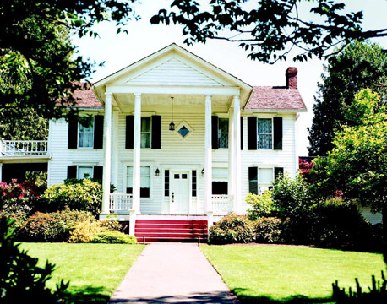
If you miss Jack at The Oregon Truffle Festival, be sure to visit The Joel Palmer House in Dayton, Oregon.

His website is www.joelpalmerhouse.com for more information, menu, and directions.

The truffle kerfuffle: mystery mushroom vanishes

They are known as the black diamonds of the Perigord – and this year, owing to the scorching summer, they are more precious than ever. Now there are even fears that the French truffle is a dying delicacy.

By: John Lichfield

Published: 15 December 2007
Dawn is breaking over Carpentras in the foothills of the Alps. France's oldest truffle market, which began nearly 600 years ago, is about to begin. The precious wares, advertised at up to €1,000 (£720) a kilo, are displayed in jam-jars, plastic ice-cream cartons and cheap wicker baskets.
The truffles – the "black diamonds of the Perigord", the "black ladies of the underground" – resemble lumps of earth or dried dog turds. In the freezing morning air, the makeshift stalls generate an intoxicating kaleidoscope of smells: fine wine, ripe cheese, mown lawns, old socks and autumn days.

continued from page 5
Customers haggle."Madame, you've given me only small ones. I'm not paying that price for crumbs." Sellers squabble. Jean, an old man in a flat cap with a face like a beetroot, announces: "The wild truffle tastes much better than the cultivated truffle. Ten times better," Emile, a man in a beret with a face like a century-old potato, says: "You talk nothing but nonsense. I defy anyone to taste any difference."
Mostly, however, there was one topic of conversation at the pre-Christmas truffle market at Carpentras yesterday (the most important market of the November-to-March truffle year). The dominant subject was the woeful shortage of truffles – and the alarmingly high prices – after another disastrous autumn-winter harvest of the mysterious subterranean mushroom in south-eastern France.
After a scorching summer in Provence and the Rhône Valley, in which it failed to rain for three months in some districts, about one tenth of the normal weight of truffles was on offer at the Carpentras market yesterday morning. Prices for the best quality large truffles in the bulk market, open only to professional buyers, reached the almost unheard of peak of €900 a kilo (and an average of €700).
"If it carries on like this, we are all dead," said Jean-Michel Cheilau, a teacher and part-time truffle producer. "You may find you have truffles in England in 10 years' time. If the climate continues to get hotter and drier, we won't have any down here. Truffles need moisture in the summer or they die or never develop. You can water the ground, and we do, but that's somehow not the same as rain."
continued on page 9

continued from page 2

Oregon Truffle Festival Tickets & Packages
All events are in the Eugene, Oregon area.
Package One: $425 per person
Includes:
- Opening - Reception and Keynote Address - Friday
- Multiple course Truffle Dinner at festival restaurants - Friday
- Winery lunch with truffle cooking demonstration - Saturday
- Truffle Hunting Foray - Saturday
- Truffle Dog Demonstration - Saturday
- Grand Truffle Dinner - Saturday
- Sunday Breakfast
- Admission to the Oregon Truffle Marketplace - Sunday
Top of Form
Package One: $425 each
Bottom of Form

Package Two: $525 per person -- Villa Evening Sold Out -- Please refer to Package #1
Includes: All Package One offerings, but instead of a restaurant dinner on Friday, Package Two guests will enjoy multi-course, truffle dinner with wine pairings at Pfeiffer Vineyards with guest chef and James Beard award winner Jack Czarnecki of The Joel Palmer House. Hosted by Danuta and Robin Pfeiffer. Villa Evening is limited to 26 guests and sells out every year, so we recommend registering quickly for this elegant offering.
- Opening - Reception and Keynote Address - Friday
- Villa Evening at Pfeiffer Vineyards
- Winery lunch with truffle cooking demonstration - Saturday
- Truffle Hunting Foray - Saturday
- Truffle Dog Demonstration - Saturday
- Grand Truffle Dinner - Saturday
- Sunday Breakfast
- Admission to the Oregon Truffle Marketplace - Sunday
Package Two: $525 each
Villa Evening Sold Out -- Please refer to Package #1

Package Three: $925 per person
Includes: Select Package One offerings plus the Truffle Growers' Forum.
- Continental breakfast and lunch - Friday
- Growers' Forum lectures - Friday
- Opening - Reception and Keynote Address - Friday
- Multiple course Truffle Dinner at festival restaurants - Friday
- Truffle Dog Demonstration - Saturday
- Truffiere tour and Winery lunch - Saturday
- Grand Truffle Dinner - Saturday
- Sunday Breakfast
- Admission to the Oregon Truffle Marketplace - Sunday
Top of Form
Package Three: $925 each

Package Four: $1025 per person -- Villa Evening Sold Out -- Please refer to Package #3
Includes: Select Package Two offerings* plus the Truffle Growers' Forum.
- Continental breakfast and lunch - Friday
- Growers' Forum lectures - Friday
- Opening - Reception and Keynote Address - Friday
- Villa Evening at Pfeiffer Vineyards - Friday
- Truffle Dog Demonstration - Saturday
- Truffiere tour and Winery lunch - Saturday
- Grand Truffle Dinner - Saturday
- Sunday Breakfast
- Admission to the Oregon Truffle Marketplace - Sunday
Package Four: $1025 each
Villa Evening Sold Out -- Please refer to Package #3

Individual Activities - Separate Admission
Grand Truffle Dinner - $150
Saturday, January 26th, 2008
Semi-formal attire please.
Advance sales only; no tickets will be sold at the door. Grand Truffle Dinner: $150 each
Top of Form
Oregon Truffle Marketplace - Sunday, January 27th, 2008
$15 at the door includes artisan foods, truffle tasting, and lecture series; or $20 includes artisan foods and truffle tasting, lecture series, commemorative OTF wine glass, and wine tastings featuring six of Oregon's premier wineries. No advance sale - Pay at the Door. Admission price includes a great Lecture series. Talk titles include: 11:30 – 12:30 "Tales from the Truffle Zone" by Dr. James Trappe, Matt Trappe, and Frank Evans; 12:30 – 1:30 “True to the Food” by Ron Paul; 1:30 – 2:30 “Pairing Oregon Truffles with Oregon Wines” by Jack Czarnecki; 2:30 – 3:30 "Traveling the Truffle Trail" by Lorraine Johnson; and 3:30 – 4:30 PM “The Oregon Truffle Industry White Paper: Whence Hence?” by David Pilz and Charles Lefevre.
Truffle Grower's Forum - Friday and Saturday Only
Expanded to two days in 2008.
For details and to Register, Click Here!

Reservations are now available for all packages and the Grand Truffle Dinner. PayPal or VISA, MasterCard, and American Express are accepted through PayPal services.
You may also send your reservation and payment with complete contact information to:
Oregon Truffle Festival LLC
P.O. Box 5275
Eugene, OR 97405-0275
If you have questions, please call or fax our office at 1.503.296.5929, or email us at info@oregontrufflefestival.com.
Chanterelles and Apples: Mistaken correlation, idiosyncratic reaction, or cryptic variable?

By David Pilz
23 October 2007

A couple of autumns ago a friend called me with a strange tale. He lives and collects chanterelles in the Oregon Coast range near the Nestucca River. He had collected a bunch of chanterelles and had some apples, so he made a dish that combined the two. After enjoying it immensely, he went to bed and had an extremely unpleasant night. He said he felt as if he was all revved up and had bad insomnia that night. Puzzled, he did not immediately associate the reaction with chanterelles or apples, each of which he eats normally without ill effect. After eating some leftovers of the dish he had prepared, he suffered another unpleasant sleepless night. That is when he postulated that somehow the combination of apples and chanterelles had caused the reaction and he called to ask if I had ever heard of such a thing.

I listened politely, but I never had, so I did not lend his hypothesis much credence. Over the subsequent years, I forgot about his story.

Last Saturday I went to my favorite spot for chanterelles in the coast range (near Summit) and collected some. The previous week I had bought a gallon of organic apple cider and was enjoying a glass or two each day. Sunday morning I cooked chanterelles for a breakfast omelet and that evening made spaghetti with chanterelles. I also had a couple of glasses of cider that afternoon. That evening I felt uneasy and restless and could not get to sleep, tossing and turning until 4 AM. I have plenty on my mind right now and just wrote it off to anxiety. Monday, I had more chanterelles for breakfast and leftover spaghetti for dinner, along with more cider during the day. In spite of being utterly exhausted from the night before, the symptoms repeated themselves and I was again unable to fall asleep until 4 AM. Insomnia 2 nights in a row is exceedingly unusual for me.

Sometime in the wee hours I put two and two together (literally, his combination of two ingredients and my combination) and remembered what he had told me.

I am still skeptical, but I tossed the remainder of my cider and am waiting to eat the rest of the chanterelles for another day or two. A web search shows plenty of recipes for chanterelles and apples, naturally so, as the fruity flavor of chanterelles pairs nicely with apples. I did not, however, find any reports of such reactions.

Did both my friend and I experience some other malady and mistakenly correlate the restlessness and insomnia with the combined consumption of chanterelles and apples? Did we each, perhaps, have similar idiosyncratic reactions to the combination? Or, is there some cryptic reason that coast range populations of Chanterellus formosus, or the soils they grow in, will precipitate this strange reaction in people? The truth is out there. Be careful staying up late in your search for it!

I look forward to hearing reader reactions to my peculiar autumnal tale. You may contact me directly if you wish (shroom@peak.org), but NATS newsletter readers might wish to hear your responses too.
(lorenmcmahill@yahoo.com).

continued from page 6
The truffle kerfuffle: Up Next Month!
Next month, the French federation of trufficulteurs, or truffle producers, has convened a conference of experts at Menherbes – near Carpentras – to discuss how to protect the most mythical and mysterious of gastronomic delicacies from becoming a victim of global warming.
The black French truffle, or tuber melanosporum, known in south-east France as the rabasse, has had a reasonable season in the south-west of the country, where it rained copiously last summer. In Provence, Languedoc and the Rhône Valley – source of 90 per cent of French truffles – the harvest has been miserable. The story is the same in northern Italy, whose "white" truffle is even more prized than the black, French truffle. Wholesale prices in Piedmont have already broken the €1,000 barrier.
Jean-François Tourrette, 28, is a truffle producer near Carpentras and technical adviser to the national truffle federation. He has been organising a series of experiments in the Provençal foothills of the Alps – the wonderful rolling hills and plateaux of limestone scrub-land described in Peter Mayle's A Year in Provence – to find ways of protecting truffles, and truffle-growers, from dry, hot summers.
"The problem is that no one really understands why and how truffles grow," he said. "There are many black holes in our knowledge. When truffles were abundant, that did not matter. If certain conditions existed – the right chalky soil, the right tree roots, the right weather – they sometimes grew and they sometimes didn't but they grew often enough to make everyone happy: the producers, the traders and the customers.
"Now they are not growing and it is vital that we find out more about what makes truffles thrive or fail. Ridiculously high prices are no good to anyone. The producers would rather sell more truffles, for less."
Truffles are underground mushrooms formed by a kind of fungal infection on the root endings of certain trees, In Provence and the Rhône Valley, they mostly attach themselves to the pubescent oak (Quercus pubescens) and holm oak (Quercus ilex). The infections, or mycorrhizes, create a two-way street of benefits, feeding sugar from the tree to the truffle and channelling minerals through the truffle into the tree.
Traditionally, truffle producers were smallhold hill farmers who gathered truffles in the wild and relied on the extra income to survive. The wild truffle has now virtually disappeared in France. Why? No one knows for sure. Drier summers? Over-exploitation? Chemicals in agriculture? Pollution in the air? The advance of forests, choking the scrubland that truffles adore?
Most truffles are now produced by planting groves of fungus-infected "truffle trees". After waiting for 15 years, the growers usually find that only one tree in 10 produces truffles. That has been enough – until now – to keep the industry alive.
A series of dry summers, and dry winters, especially the blazing summer of 2003, has had a devastating effect on even the cultivated truffles. The legally recorded harvest in France will struggle to reach 15 tonnes this year, compared to 50 tonnes a few years ago (and 1,200 tonnes in the 19th century).
"Truffles need moisture but some truffles, in some conditions, seem to thrive even when it is dry. Why? Can we learn from that? Can we learn how to create those conditions? That's what our experiments – and this conference – are trying to discover," said M. Tourrette.
The shortage, and high price, of truffles has generated a wave of truffle-related crime in recent years: midnight raids on truffle plantations; the armed theft of cash from truffle traders; even the rustling of champion truffle-sniffing dogs.
At the Carpentras market yesterday, there was a strange mixture of pre-Christmas festivity and edgy furtiveness. "Don't talk about my dogs," one producer said. Another man boasted that he had received €870 a kilo – almost the market peak – because his truffles were so fine. How many of them did he sell? "No need to say that," he said. "The people of Britain don't need to know that. Not my neighbours either. I don't want to attract attention. Did you know that one in three of all truffles sold in France is stolen?"
From before dawn, there were a dozen stall-holders selling truffles in small quantities to individuals. (Christmas means truffles to the French.) Some of the truffles were as big as a man's fist. Others were no bigger than hazel-nuts. One, the size of a chestnut, was placed with pride in its own basket with an individual price tag: a snip at €23.
At 9am sharp a bell was rung by the "Monsieur Truffe" of Carpentras, the mayor's chief truffle official, André Desserre. This was the sign to begin the real business of the day.
Forty truffle producers lined the outer edges of a square of tables, erected on the terrace of the Restaurant de L'Univers. Before them they cautiously laid out their hoard of truffles, some in elaborate cloth sacks, and some in supermarket plastic bags. One woman in her sixties brought a small collection of truffles in her handbag. Some sellers looked embarrassed to have so little. Others looked delighted, or embarrassed, to have so much.
M. Desserre stood beside the only gap in the square of tables, barring entry to anyone but authorized bulk buyers: truffle "courtiers" or traders; owners of truffle conserve factories; and restaurateurs. Seventeen buyers entered the square. A beefy, elderly woman wearing a brown Stetson elbowed younger traders aside to reach her favorite seller. She had earlier introduced herself as the owner of a truffle conserve business. She declined to say more or give her name.
The buyers toured the square, making almost silent deals with the sellers. After each trade, they handed over a kind of cloakroom ticket, on which was scribbled the agreed price and quantity and their name. Within 20 minutes, everything on offer – 130kg, compared to a tonne, or 1,000kg in a "good year" at Carpentras market in the week before Christmas – had been sold. M. Desserre, the officiating Monsieur Truffe, in brown hat and red scarf, then kindly allowed The Independent to enter the square to look into the bags of truffles.
These were an altogether higher class of underground mushroom than those on sale to the general public. Some were as large as cooking apples. Others had achieved fantastic shapes or were in psychedelic whirls of brown and black.
"This market has been here since the early 15th century," said M. Desserre. "How much longer it will survive, I don't know. Some of these truffles are excellent, but the quantity is miserable. This is usually the best-stocked market of the year, because prices reach their peak just before Christmas."
Everyone adjourned to the two neighboring bars. Here, the cloakroom tickets were handed back to the buyers. Truffles were weighed at the café tables on ancient, hand-held, weighing hooks. Thick wads of €50 notes, and thinner wads of €500 and €100 notes, were passed from hand to hand. Occasionally, a check was signed.
The entire bar took on the heady aroma of mingled cigarette smoke and truffles. But what is all the fuss about? Are truffles really worth so much money? Emile Joumand, a 64-year-old estate agent, had driven 40 miles from a town near the mouth of the Rhône to buy a few truffles for his family Christmas dinner. He drove a hard bargain for the tiniest truffle pebbles on offer at the public section of the market and got 300g – almost a third of a kilo – for €85.
"Even that is a lot of money," he said. "But, to the family, Christmas would not be Christmas without truffles. I will make an hors d'oeuvre with truffles and foie gras and vegetables in a pasty crust. It is always exquisite."
Personally, my experience of truffles is limited. I once had a truffle omelette in a small restaurant not far from Carpentras, with copious shavings of a truffle that I was given by a generous producer. Eaten that way, truffles are as different from white button mushrooms as Shakespeare from Jeffrey Archer, or a bottle of €1 plonk from a vintage Burgundy.
On the night before the truffle market, I treated myself to a €28 truffle omelette in a restaurant in Carpentras. Minuscule splinters of truffle were sprinkled over the eggs like pepper from a blocked shaker. I could taste the eggs but not the truffles. That is the price you pay for global warming.
Source: http://news.independent.co.uk/europe/article3253091.ece

Editor’s Note:
Hi all,
Hope you enjoy this (and I apologize for my tardiness) edition of “The Truffler.” Being new to NATS it’s been quite a learning experience being the newsletter editor, but wonderfully fun. Originally, I had a plan to have had this issue ready a month ago. But of course, various circumstances reared their heads.
If anyone has suggestions, requests or wants to submit articles please contact me. There’s plenty more in the works for future issues. We have “Ask the Expert” questions being mulled over by our experts. And we’ll have more info on this year’s truffle market including current prices, types to be found, places they can be sampled, and of course more club foray results, new members and new identifications. Feedback is always appreciated, if anyone has any considerations please let me know.
Contact me at lorenmcmahill@yahoo.com for any reason you may need to.

2008 Membership Dues
NATS Annual membership is from January 1 to December 31 each year. Dues are tax deductible to the full extent allowed by law. Renew your dues with this form and keep your cancelled check as your receipt. Fill in and mail your check made out to:
NATS
P.O. Box 296
Corvallis, Oregon 97339-0296
Name(s): Phone: ( )
Address: Zip
Email:
First family member ------------------------------$10.00 Foreign Membership -------------$15.00
Each additional family member ---------------$5.00 Contributor---------------------------$50.00 - $499.00
(must live in same household)
Sustaining member-------------------------------$500.00

North American Truffling Society  P.O. Box 296  Corvallis Oregon 97339 |  | Non Profit Org  U.S. Postage  Paid  Corvallis, OR.  Permit No. 104

